 

**A GAMIFIED LITERACY ANALYSIS OF INDIAN CONSUMER PROTECTION LAWS**

**PROJECT REPORT**

***Submitted by***

|  |  |
| --- | --- |
| **KEERTHANA K** | **211720104077** |
| **MAHALAXMI K** | **211720104088** |

***in partial fulfillment for the award of the degree of***

**BACHELOR OF ENGINEERING IN**

**COMPUTER SCIENCE AND ENGINEERING RAJALAKSHMI INSTITUTE OF TECHNOLOGY ANNA UNIVERSITY: CHENNAI 600 025**

**MAY 2024**

ANNA UNIVERSITY: CHENNAI 600 025

# BONAFIDE CERTIFICATE

Certified that this project report **A GAMIFIED LITERACY ANALYSIS OF INDIAN CONSUMER PROTECTION LAWS** is the bonafide work of **KEERTHANA K (211720104077),MAHALAXMI K (211720104088),** who

carried out the project work under my supervision.

|  |  |
| --- | --- |
| **SIGNATURE** | **SIGNATURE** |
| **SUPERVISOR**  **Mr.M.Ashok M.Tech., (Ph.D)**  **Assistant Professor (SS) Department of Computer Science And Engineering** | **HEAD OF THE DEPARTMENT Dr. R SARAVANAN**  **Associate Professor**  **Department of Computer Science And Engineering** |
| **Rajalakshmi Institute of Technology**  **Chennai 600 124.** | **Rajalakshmi Institute of Technology**  **Chennai 600 124.** |

# ACKNOWLEDGEMENT

We express our sincere gratitude to our honorable Chairman **Thiru. S.MEGANATHAN, B.E., F.I.E.,** Chairperson **Dr.(Mrs.)THANGAM**

**MEGANATHAN, M.A., M.Phil., Ph.D.,** Vice Chairman **Dr HAREE SHANKAR MEGANATHAN** for their constant encouragement to do this project and also during the entire course period

We thank our Principal **Dr. N BHALAJI** and our Head of the department **Dr. R SARAVANAN** for their valuable suggestions and guidance for the development and completion of this project.

We also extend our gratitude to our Project coordinator **Dr. V ANJANA DEVI, Professor** and our Supervisor **Mr.M.ASHOK , Assistant Professor(SS)** who took special interest on our project and gave their consistent guidance during all stages of this project.

Finally, we thank all the teaching and non-teaching faculty members of the

# DEPARTMENT OF COMPUTER SCIENCE AND ENGINEERING who

helped us to complete this project.

Above all we thank our parents and family members for their constant support and encouragement for completing this project.

# CERTIFICATE OF EVALUATION

|  |  |
| --- | --- |
| **College Name** | **2117 - Rajalakshmi Institute of Technology** |
| **Branch & Semester** | **Computer Science and Engineering & 8th Semester** |
| **Subject** | **CS8811 PROJECT WORK** |

|  |  |  |  |
| --- | --- | --- | --- |
| **S.NO.** | **NAME OF THE STUDENTS** | **TITLE OF THE PROJECT** | **NAME OF THE SUPERVISOR WITH DESIGNATION** |
| 1 | KEERTHANA K (211720104077) | A GAMIFIED LITERACY ANALYSIS OF INDIAN CONSUMER  PROTECTION LAWS | Mr. M.ASHOK  Assistant Professor(SS) Dept. of Computer Science and  Engineering |
| 2 | MAHALAXMI K |
|  | (211720104088) |  |

The report of this project work submitted by the above

students in partial fulfillment for the award of Bachelor of Engineering degree in COMPUTER SCIENCE AND ENGINEERING under Anna University was evaluated and confirmed to be the reports about the work done by the above students.

The University viva-voce is held on

.

# INTERNAL EXAMINER EXTERNAL EXAMINER

**ABSTRACT**

The innovative integration of gamified elements to analyze Indian consumer protection laws, with a dual focus on enhancing understanding and encouraging responsible behavior within the gaming community. The study adopts a gamified literacy approach, utilizing interactive modules to make the complex legal landscape accessible and engaging. By merging ethical considerations with legal knowledge, the gameplay experience not only educates users on their consumer rights but also instills a sense of responsibility within the gaming community. The research explores the design and implementation of gamified modules, ensuring they strike a balance between entertainment and educational depth. Real-world case studies showcase successful applications, highlighting the potential of this approach to transform consumer rights education. The study concludes by emphasizing the broader societal impact, envisioning a community of informed consumers and responsible gamers who navigate the legal landscape with confidence and ethical awareness. This gamified literacy analysis provides a novel perspective on consumer protection education, offering a dynamic and interactive means to empower individuals while fostering responsible behavior in the gaming community.

# Keywords:

Gamified elements,Indian consumer protection laws,Responsible behavior,Gamified literacy approach,Interactive modules

# TABLE OF CONTENTS

**CHAPTER NO. TITLE PAGE NO.**

# ABSTRACT i

**LIST OF FIGURES** x

LIST OF TABLES xi

1. INTRODUCTION 1
   1. RESEARCH TOPIC OVERVIEW 3
      1. CONSUMER PROTECTION DEFINITION 3

AND SCOPE

* + 1. LEGAL LITERACY AND EDUCATION 3

OVERVIEW

* 1. STUDY BACKGROUND 4
     1. HISTORICAL EVOLUTION OF 4

CONSUMER PROTECTION LAWS

* + 1. GLOBAL VIEWS ON CONSUMER 5

RIGHTS

* 1. PROBLEM STATEMENT 5
     1. FINDING VIOLATIONS OF CONSUMER 5

RIGHTS

* 1. RESEARCH OBJECTIVES 6
     1. SUPPLEMENTARY GOALS 6
  2. DEVELOPING HYPOTHESES 6
     1. RESEARCH ISSUES 7
     2. ANTICIPATED RESULTS 7
  3. THE STUDY'S SIGNIFICANCE 8
     1. THE PRACTICAL IMPLICATIONS FOR 8

CONSUMER WELFARE

* + 1. THE ACADEMIC INPUT INTO LEGAL 8

EDUCATION

* 1. THE STUDY'S PURPOSE AND 9

CHALLENGES

* + 1. THE STUDY’S PURPOSE AND 9

LIMITATIONS

* + 1. TIME RESTRAINTS 10
  1. DEFINITION OF KEY TERMS 10
     1. CONSUMER PROTECTION 10
     2. LEGAL LITERACY 11
     3. GAMIFICATION 11
  2. METHODOLOGICAL APPROACH 11
     1. DESIGN OF RESEARCH 12
     2. TECHNIQUES FOR DATA COLLECTION 12
     3. METHODS OF DATA ANALYSIS 13
  3. MORAL POINTS TO REMEMBER 14
     1. CONFIDENTIALITY OF PARTICIPANTS 14
     2. PROCEDURES FOR INFORMED 15

CONSENT

* + 1. PROTECTION OF VULNERABLE 15

POPULATIONS

* 1. SUMMARY 15

# LITERATURE SURVEY 16

* 1. INTRODUCTION 16
  2. REGULATIONS CONCERNING CONSUMER 16

PROTECTION (MEDIATION)

* + 1. THE SIGNIFICANCE OF MEDIATION IN 17

ONLINE CONSUMER CONFLICTS

* + 1. MODIFIED CONSUMER DISPUTE 18

MEDIATION PROCESS

* + 1. ANALYSIS OF INCENTIVE 18

STRUCTURES USING GAME THEORY

* 1. CONSUMER PROTECTION LAWS AND THE 19

ONLINE GAMING INDUSTRY

* + 1. ESTABLISHING CENTRALISED 19

REGULATIONS FOR REAL-MONEY GAMES

* + 1. DECEPTIVE PROMOTIONS AND 20

ENDORSEMENTS

* 1. CONSUMER RIGHTS AND LANDMARK 21

DECISIONS

* + 1. THE FUNCTION OF THE GOVERNMENT 22

IN UPHOLDING CONSUMER RIGHTS

* + 1. CONSUMER INVOLVEMENT 22
  1. DATA SECURITY AND PRIVACY FOR 23

CUSTOMERS

* + 1. DANGER OF UNAUTHORIZED ACCESS 23

TO PERSONAL INFORMATION

* + 1. PRIVACY LAWS AND LEGAL 24

OBLIGATIONS

* + 1. POSSIBLE LAW FOR PROTECTION OF 25

PERSONAL INFORMATION

* + 1. THE GREATEST ORGANIZATIONAL 25

PRIVACY POLICIES

* 1. THE LAW REGARDING VIDEO GAMES 26

AND PROTECTION OF USERS

* + 1. VIDEO GAME CATEGORIZATION 27
    2. MONETARY RECOMPENSE FOR 28

WRITERS

* + 1. RIGHT HOLDERS AND 28

STAKEHOLDERS

* + 1. PROFESSION-BASED GAMERS' LEGAL 29

SITUATION

* 1. EMERGING ISSUES AND FUTURE 30

TRENDS

* + 1. THE DIGITAL AGE CHANGING 31

ENVIRONMENT FOR CONSUMER PROTECTION LAWS

* + 1. CHANGES IN TECHNOLOGY AND 32

THEIR EFFECT ON CONSUMER RIGHTS

* + 1. REGULATORY ORGANIZATIONS' 33

OBSTACLES AND OPPORTUNITIES

* 1. CASE RESEARCH AND ILLUSTRATIONS 34
     1. AN EXAMINATION OF LATE 35

GAMING INDUSTRY CONSUMER

PROTECTION CASES

* + 1. STUDIES OF CASES SHOWING 36

SUCCESSFUL MEDIATION TECHNIQUES

* + 1. DATA BREACH EXAMPLES AND THE 37

LEGAL REPERCUSSIONS

* 1. RECENT RESEARCHES 37
  2. SUMMARY 45

# SYSTEM DESIGN 46

* 1. INTRODUCTION 46
  2. SYSTEM ARCHITECTURE 46
  3. PROCESS FLOW 47
  4. DATA FLOW MODEL 49
     1. DFD LEVEL 0 49
     2. DFD LEVEL 1 50
     3. DFD LEVEL 2 51
  5. UML DIAGRAMS 54
     1. USE CASE DIAGRAM 54
     2. ACTIVITY DIAGRAM 56
     3. CLASS DIAGRAM 57
     4. SEQUENCE DIAGRAM 58
  6. SUMMARY 59

# SYSTEM IMPLEMENTATION 60

* 1. INTRODUCTION 60
  2. NAIVE BAYES ALGORITM 60

INTEGRATION

* 1. OVERVIEW OF THE PYGAME

61

* 1. CUSTOMIZING NAIVE BAYES 62

DIFFICULTY LEVELS

* 1. COMBINING THE NAIVE 63

BAYES ALGORITHM WITH QUIZZES

* 1. SUMMARY 64

# TESTING 65

* 1. INTRODUCTION 65
  2. TESTING THE GAMIFIED MODEL 65
  3. TEST CASES 66
     1. MODULE-1 CONSUMER RIGHTS 66

AND RESPONSIBILITIES

* + 1. MODULE-2 LEGAL FRAMEWORK 68

AND CASE STUDIES

* + 1. MODULE-3 GAMIFIED QUIZZES 69

AND CHALLENGES

* + 1. MODULES TESTED 71
  1. SUMMARY 72

# EXPERIMENTAL ANALYSIS 73

* 1. INTRODUCTION | 73
  2. ANALYSIS 73
     1. PLAYER ENGAGEMENT METRICS 74
     2. GAME PERFORMANCE ANALYSIS 74
     3. LEARNING PROGRESS TRACKING 75
  3. GAME DIFFICULTYADJUSTMENT 75
  4. PLAYER DATA ANALYSIS 76
     1. CAPTURING AND ANALYZING 76

PLAYER INTERACTIONS

* + 1. PERSONALIZED LEARNING 76

EXPERIENCES

* 1. TESTING AND IMPROVEMENT 76
     1. EVALUATION OF QUIZ 76

EFFECTIVENESS

* + 1. CONTINUOUS IMPROVEMENT 77

STRATEGIES

* 1. SUMMARY AND CONCLUSION 77

# FUTURE WORK 78

* 1. INTRODUCTION 78
  2. ADVANCED ADAPTIVE LEARNING 78

ALGORITHMS

* + 1. RESEARCH AND IMPLEMENTATION 78
    2. PERSONALIZATION ENHANCEMENT 79
  1. EXPANSION OF LEGAL CONTENT 79
     1. CONTENT DIVERSITY 79
     2. REGIONAL VARIATIONS 79
  2. MULTIPLAYER AND COLLABORATIVE 80

LEARNING

* + 1. MULTIPLAYER INTEGRATION 80
    2. TEAM-BASED CHALLENGES 80
  1. GAMIFIED LEARNING ANALYTICS 80
     1. DATA-DRIVEN INSIGHTS 80
     2. GAMIFICATION OF FEEDBACK 81
  2. COMMUNITY ENGAGEMENT AND USER- 81

GENERATED CONTENT

* + 1. COMMUNITY FORUMS 81
    2. USER-GENERATED CONTENT 81
  1. CONTINUOUS IMPROVEMENT AND 82

FEEDBACK LOOP

* + 1. ITERATIVE DEVELOPMENT 82
    2. USER FEEDBACK MECHANISMS 82
  1. SUMMARY 82

APPENDIX A APPENDIX B APPENDIX C APPENDIX D

# APPENDICES

SAMPLE SCREENSHOTS A1

SAMPLE CODING B1

SYSTEM REQUIREMENTS C1

PUBLICATIONS D1

# REFERENCES R1

**LIST OF FIGURES**

|  |  |  |
| --- | --- | --- |
| **FIGURE NO.** | **TITLE** | **PAGE NO.** |
| 3.1 | SYSTEM ARCHITECTURE | 47 |
| 3.2 | PROCESS FLOW DIAGRAM | 48 |
| 3.3 | DFD LEVEL 0 | 49 |
| 3.4 | DFD LEVEL 1 | 50 |
| 3.5 | DFD LEVEL 2 | 51 |
| 3.6 | DFD LEVEL 2 | 52 |
| 3.7 | DFD LEVEL 2 | 53 |
| 3.8 | DFD LEVEL 2 | 54 |
| 3.9 | USE CASE DIAGRAM | 55 |
| 3.10 | ACTIVITY DIAGRAM | 56 |
| 3.11 | CLASS DIAGRAM | 57 |
| 3.12 | SEQUENCE DIAGRAM | 59 |
| A1.1 | VISUAL STUDIO CODE | A1 |
| A1.2 | SAMPLE DATASET | A1 |
| A1.3 | GAME MODE 1 | A2 |
| A1.4 | Q&A GENERATION 1 | A3 |
| A1.5 | Q&A GENERATION 2 | A4 |

# LIST OF TABLES

|  |  |  |
| --- | --- | --- |
| **TABLE NO.** | **TITLE** | **PAGE NO.** |
| 5.1 | TEST CASE FOR MODULE-1 CONSUMER | 67 |
|  | RIGHTS AND RESPONSIBILITIES |  |
| 5.2 | TEST CASE FOR MODULE -2 LEGAL | 68 |
|  | FRAMEWORK AND CASE STUDIES |  |
| 5.3 | TEST CASE FOR MODULE -3 GAMIFIED | 70 |
|  | QUIZZES AND CHALLENGES |  |

**CHAPTER-1 INTRODUCTION**

In an era where digital technology and gaming culture intersect with the legal landscape, there emerges an unprecedented opportunity to revolutionize the way individuals engage with and comprehend consumer rights and legal protections. This research endeavors to bridge the gap between legal literacy and accessibility by proposing a groundbreaking approach: a gamified literacy analysis of Indian consumer protection laws. Recognizing the challenges posed by the intricate legal frameworks and the imperative to foster responsible behavior, this study aims to harness the captivating power of gamified elements to increase understanding, engagement, and ethical awareness within the gaming community.Consumer rights education remains a pivotal aspect of a fair and equitable society, ensuring individuals are informed, empowered, and capable of navigating the complexities of the marketplace. However, traditional approaches often struggle with disengagement and accessibility issues, especially among younger demographics immersed in digital experiences. Simultaneously, the gaming community, with its vast and diverse user base, presents an untapped opportunity to reach individuals in an environment where they are already highly engaged.

The intersection of gamification, ethical considerations, and legal knowledge presents a dynamic solution to transform consumer rights education. By infusing the gameplay experience with ethical principles and legal insights, this research aims not only to educate but also to cultivate a sense of responsibility within the gaming community. The incorporation of gamified elements seeks to make learning a more interactive, enjoyable, and effective process, breaking down the barriers that often hinder the understanding of legal concepts.

This research acknowledges the unique socio-cultural context of India, a country with a rich gaming culture and a rapidly evolving legal landscape, particularly in the realm of consumer protection. As the second-most populous country globally, with a significant youth demographic, India stands at the forefront of the digital revolution, presenting an opportune environment to implement and assess the impact of gamified legal literacy initiatives.

The rationale behind the gamified literary analysis lies in its potential to cater to different learning styles, making legal knowledge not only accessible but also relatable and memorable. By engaging users in a virtual environment where they actively participate in deciphering legal principles, the research anticipates a more profound and lasting impact on their understanding of consumer rights. Moreover, the incorporation of ethical considerations aims to instill a sense of responsibility, fostering a gaming community that not only enjoys immersive experiences but also recognizes and upholds ethical standards.

The design and implementation of gamified modules tailored to the intricacies of Indian consumer protection laws will be a central focus of this research. Attention will be given to striking a balance between engagement and educational depth, ensuring that the gameplay experience remains both entertaining and informative. Real-world case studies of successful gamified initiatives within the Indian context will be explored, providing practical insights into the potential efficacy of this approach.

This research embarks on an interdisciplinary journey, drawing from educational psychology, game design, legal studies, and ethics to create a holistic framework for gamified legal literacy. It seeks to contribute not only to the academic discourse surrounding legal education but also to the practical implementation of innovative approaches that resonate with the digital-savvy generation.

In this envisioned future, gaming serves as more than just a recreational pastime; it becomes a platform for meaningful engagement and learning. By weaving ethical dilemmas into gameplay narratives and integrating legal concepts seamlessly into game mechanics, developers inspire players to consider the broader implications of their actions. This heightened awareness extends beyond the confines of virtual worlds, influencing real-world decision-making and fostering a sense of responsibility towards others. As gamers become increasingly adept at navigating the ethical complexities of virtual environments, they also develop crucial skills for navigating the complexities of the modern digital landscape. Armed with legal literacy, they can advocate for their rights and demand transparency and accountability from game developers and platform providers. Moreover, this collective consciousness within the gaming community sparks dialogue and collaboration, driving forward social progress and paving the way for a future .

# RESEARCH TOPIC OVERVIEW

**Overview:** The goal of this study is to determine whether gamification can effectively inform and empower customers about their legal rights and obligations in India. Consumer protection laws are essential for defending the rights of consumers in India, yet the general public still doesn't know much about them. This project aims to increase the effectiveness, accessibility, and engagement of legal education through the use of gamification, which is the application of game-design elements and principles to non-gaming contexts.

# CONSUMER PROTECTION DEFINITION AND SCOPE

The term "consumer protection" describes the body of rules, laws, and policies aimed at defending customers' rights and interests when they deal with companies and service providers. It seeks to safeguard buyers and sellers against dishonest, unjust, or fraudulent activities by ensuring fair and open dealings.Rules pertaining to fair trade, consumer rights, and standards for product safety are all included. To reduce dangers to customers, requirements for testing and manufacturing are determined by product safety procedures. Transparency in contracts is guaranteed by fair trade rules, which forbid misleading activities like deceptive advertising. Consumer rights include choice, remedy, privacy protection, and accurate information. Banking, credit, lending, and debt collecting activities are governed by financial safeguards. With the knowledge of their rights and available options for resolving disputes, customers are empowered by education campaigns. Furthermore, digital privacy issues are covered by privacy and data protection legislation. The overall goal of consumer protection is to advance economic stability and consumer welfare by encouraging fairness, trust, and transparency in the marketplace.

# 1.1.2 LEGAL LITERACY AND EDUCATION OVERVIEW

The goal of legal literacy and education is to improve people's understanding of the law, their rights, and how the legal system works. To facilitate the efficient handling of legal matters, they disseminate information on legal principles, procedures, and processes. These programmes provide educational programmes

and resources to the general population, irrespective of background, with an aim towards accessibility and clarity. Legal literacy initiatives empower people by raising their level of awareness and comprehension of their legal rights and duties. Legal education also promotes civic duty, critical thinking, and problem-solving abilities. In the end, these initiatives help people get justice, which empowers them to stand up for their rights and makes society more knowledgeable and engaged.

# STUDY BACKGROUND

The research highlights the general public's inadequate comprehension of Indian consumer laws, despite their crucial function in safeguarding consumer rights. There is potential to effectively close this knowledge gap given the growing interest in cutting-edge teaching strategies like gamification. Gamification, or the incorporation of game features into non-gaming environments, has the potential to increase the effectiveness and participation of legal education. Its applicability to Indian consumer legislation, however, is yet mainly unknown. Therefore, the purpose of this study is to assess how well gamified methods of consumer education on their rights and responsibilities work. Through the integration of consumer psychology, education theory, and legal studies, this study aims to design and evaluate a customized gamified platform that will offer valuable insights to educators and policymakers.

# HISTORICAL EVOLUTION OF CONSUMER PROTECTION LAWS

Over the course of centuries, regulations protecting consumers have changed to reflect the need for ethical and secure business activities. Modern consumer protection evolved in response to mass production brought about by industrialization, drawing inspiration from the primitive laws of ancient civilizations. The founding of consumer advocacy organisations, the passing of legislation pertaining to product safety, and the establishment of regulatory bodies are notable developments. Globalization and technology breakthroughs in the late 20th and early 21st centuries required worldwide collaboration to harmonies standards. The historical trend shows how consumer rights are becoming more widely acknowledged, as well as how important it is to regulate business activities to ensure fairness and openness in the marketplace.

# GLOBAL VIEWS ON CONSUMER RIGHTS

Global perspectives on consumer rights differ according to legal, cultural, and economic factors. Developed countries frequently have strong legal protections for consumers, including rules pertaining to fair trade practices and product safety. On the other hand, inadequate resources and lax regulatory frameworks in some developing nations may make it more difficult to effectively enforce consumer rights. However, there is a rising body of international agreement about how critical consumer protection is to building confidence and stability in the economy. International bodies such as the United Nations support uniform regulations and international collaboration while fighting for the rights of consumers. Notwithstanding differences, protecting consumers from exploitation, guaranteeing access to safe products, and offering channels for recourse are always the fundamental objectives. The goal of this group endeavor is to protect basic consumer rights and increase consumer trust in global marketplaces.

# PROBLEM STATEMENT

1. Reading and Understanding Indian consumer protection laws.
2. Approaching and Applying respective laws in corresponding scenarios

# FINDING VIOLATIONS OF CONSUMER RIGHTS

Finding instances of consumer rights abuses requires a multimodal strategy. It suggests that there exist multiple tactics or approaches that can be employed in the place of a single strategy for identifying instances of consumer rights violations. The purpose of this introduction is to lay the groundwork for a more detailed discussion of the various approaches and procedures that can be used to identify instances of consumer rights violations. These approaches and procedures may include, but are not limited to, regulatory compliance checks, mystery shopping, market trend analysis, consumer complaint monitoring, regulatory agency collaboration, and more. In summary, it implies that a thorough strategy is required to successfully detect and resolve consumer rights violations.The goal of this group endeavor is to protect basic consumer rights and increase consumer trust in global marketplaces.

# RESEARCH OBJECTIVES

1. Enhance Consumer Awareness: Increase understanding of consumer rights and legal protections through gamified elements, making the learning process engaging and accessible.
2. Promote Ethical Gaming Practices: Encourage responsible behavior within the gaming community by integrating ethical considerations and legal knowledge into the gameplay experience.

# SUPPLEMENTARY GOALS

Through interactive gaming, gamified literacy analysis of Indian consumer protection laws aims to promote behavioral change and increase participation. It is imperative to guarantee diversity by accommodating a range of ethnic and literacy backgrounds. It is essential to provide consumers with the information and abilities they need to express their rights with confidence while encouraging community cooperation. Systemic change can also be sparked by promoting legislative changes and gathering data for evidence-based decision-making. Other key goals include maintaining long-term involvement, guaranteeing accessibility, and incorporating the game into official schooling. These additional objectives increase the project's influence by promoting a more knowledgeable consumer culture in India and a better understanding of consumer rights.

# DEVELOPING HYPOTHESES

Developing Hypotheses for a Gamified Literacy Analysis of Indian Consumer Protection Laws involves formulating testable predictions. Hypotheses may include expectations of increased engagement, improved understanding, and behavioral changes among players. Additionally, hypotheses might suggest empowerment and increased advocacy as outcomes of game participation. Predictions could also encompass long-term impacts, inclusivity, and policy influence resulting from the game. Moreover, hypotheses may propose educational integration benefits and accessibility impacts for diverse audiences. These hypotheses serve as foundational statements guiding research and evaluation efforts, aiming to assess the effectiveness and potential outcomes of using gamified

approaches to enhance understanding and application of consumer protection laws in India.

# RESEARCH ISSUES

Evaluating the efficacy of gamification in broadening comprehension among various groups is one of the research questions in a gamified literacy analysis of Indian consumer protection regulations. To guarantee resonance with Indian viewers, cultural sensitivity must be taken into account. Meeting the needs of people with disabilities and those with linguistic problems requires accessibility. It is imperative to examine how the game affects consumer behavior, how it is incorporated into formal schooling, and how to maintain long-term involvement. Key study considerations include generating appropriate evaluation metrics, guaranteeing data security, and investigating its potential to impact policy decisions. Strategies for community engagement are also essential, such as collaborations with advocacy organizations and legal professionals. Resolving these problems will increase the game's effectiveness in improving legal literacy and giving Indian customers more influence.

# ANTICIPATED RESULTS

The gamified literacy analysis of Indian consumer protection laws holds promise not only for heightened engagement but also for fostering a deeper understanding of legal rights and responsibilities among participants. Through interactive gameplay mechanics, players are not merely passive recipients of information but active participants in their own learning process, leading to more meaningful comprehension and retention of complex legal concepts. This immersive approach is expected to instill a sense of empowerment among gamers, equipping them with the knowledge and confidence to assert their rights as consumers and challenge unethical business practices. Moreover, the potential for gamers to become advocates for consumer protection signifies a shift towards active citizenship and social responsibility within the gaming community. By leveraging the reach and accessibility of gaming platforms, this initiative has the capacity to reach diverse demographics, transcending traditional barriers to legal education and facilitating widespread awareness and engagement. Introducing the game into educational settings further enhances its impact, offering educators a dynamic tool to enhance learning outcomes and promote legal literacy among students.

# THE STUDY'S SIGNIFICANCE

The study's novel application of gamification to examine and raise awareness of consumer protection legislation in India is what makes it significant. Through gameplay, it attempts to democratize legal understanding among a wide range of groups by making intricate legal concepts approachable and entertaining. It aims to provide people the tools they need to successfully claim their rights by influencing consumer behavior. The results have the ability to guide policy decisions by providing useful information on how to improve consumer protection and regulatory frameworks. Additionally, integration into educational environments can promote a legal literacy culture among teachers and students, encouraging a proactive approach to consumer rights from an early age. In the end, the study helps the Indian economy and consumers by advancing the larger social objective of encouraging justice, responsibility, and openness in business dealings.

# THE PRACTICAL IMPLICATIONS FOR CONSUMER WELFARE

The study has significant practical ramifications for consumer welfare. By using gamified techniques to improve legal literacy, consumers are better equipped to protect their rights and interests during transactions by navigating them with knowledge and confidence. Consumers with more authority are better able to spot infractions and take action, which increases company and service provider accountability. This promotes a more open market where dishonest behavior is discouraged and ethical behavior is rewarded.

The results of the study can also be used to guide policy choices that aim to bolster consumer protection legislation, which will ultimately help to create a more secure and fair environment for consumers. In general, the practical consequences encompass higher market openness, prospective legislative improvements, and increased consumer empowerment, all of which contribute to improved consumer welfare in India.

# THE ACADEMIC INPUT INTO LEGAL EDUCATION

Incorporating gamified approaches into legal education offers significant academic input with wide-ranging benefits. By integrating interactive and engaging methods,

such as gamification, into legal curricula, educators can enhance student engagement and comprehension of complex legal concepts, including consumer protection laws. This innovative approach not only fosters a deeper understanding but also cultivates critical thinking, problem-solving, and decision-making skills among students. Moreover, gamified legal education encourages active participation and collaboration, creating a dynamic learning environment that mirrors real-world scenarios. By embracing such pedagogical innovations, academic institutions contribute to producing well-rounded legal professionals equipped with practical knowledge and skills essential for addressing contemporary legal challenges, ultimately enriching the quality and effectiveness of legal education.

# THE STUDY'S PURPOSE AND CHALLENGES

The goal of the project is to find out how well gamified methods can raise legal awareness of consumer protection legislation in India. It looks at how they affect behavior, comprehension, and the applicability of policies.

# CHALLENGES

1. **Language Barrier:** Designing content that effectively communicates consumer rights and legal concepts in multiple languages to overcome language barriers prevalent in a diverse country like India.
2. **Limited Applicability for Non-Indian Players:** Communicating clearly that the content is specific to Indian consumer laws, minimizing potential confusion or misinformation for players from other jurisdictions.

# THE STUDY'S PURPOSE AND LIMITATIONS

The study covers a wide range of geographic regions in India, including semi-urban, rural, and metropolitan areas. It seeks to capture the variety of experiences and viewpoints surrounding consumer protection laws by using a broad geographic coverage. This all-encompassing strategy guarantees representation from many cultural and socioeconomic circumstances, which enhances the study's validity and national applicability. It is also possible to

identify potential differences or difficulties in legal literacy and consumer welfare that may differ depending on geography by looking at a variety of geographic regions. In order to improve consumer rights and legal literacy on a national level, the study takes into account the distinctive qualities and difficulties that exist in various regions of India. The study's ultimate goal is to offer insights and recommendations that are applicable and significant nationwide.

# TIME RESTRAINTS

The research is conducted within precise time constraints to guarantee effective completion and prompt distribution of results. Deadlines for data collection, processing, and reporting are a few examples of these restrictions. Following set deadlines makes it possible to handle resources efficiently and optimizes the study's impact within the allotted period. Time constraints can also affect the breadth and depth of the study, requiring that important goals and techniques be prioritized. Nonetheless, rigorous planning and project management techniques can lessen the difficulties that may arise from time limits, guaranteeing that the study meets project deadlines and accomplishes its objectives.

# DEFINITION OF KEY TERMS

# CONSUMER PROTECTION

The laws, rules, and programmes aimed at defending the rights and interests of consumers in business dealings are collectively referred to as consumer protection measures. These safeguards could include provisions for guaranteeing the security of products, reasonable prices, truthful advertising, open disclosure of information, and procedures for settling conflicts between customers and companies. Establishing an equitable and open market is the aim of consumer protection, allowing customers to make knowledgeable choices, have faith in the security and caliber of products and services, and have channels for redress in the event that their rights are infringed. The study's ultimate goal is to offer insights and recommendations that are applicable and significant nationwide. To maximize the effectiveness of gamification techniques in certain fields.

# LEGAL LITERACY

The knowledge and comprehension of legal rights, obligations, and procedures within a particular legal system is referred to as legal literacy. It includes understanding fundamental legal ideas, such as legal rights and obligations, as well as being acquainted with the court system and its processes for obtaining justice. The ability to navigate legal difficulties, make educated judgements, and effectively fight for one's rights are all made possible by legal literacy. It is essential for expanding access to justice, giving people the authority to defend their own interests, and creating a legal culture in society.

# GAMIFICATION

Gamification is the process of applying mechanics and ideas of game design to non-gaming environments in order to improve learning outcomes, motivation, and engagement. It usually entails adding components to tasks or procedures to make them more engaging and entertaining, such as points, badges, leaderboards, challenges, and prizes. Gamification can be applied in educational settings to increase student engagement and effectiveness through the provision of incentives for involvement, the promotion of competition, and the advancement of skill and knowledge mastery.

Gamification can be used in legal education or analysis to improve comprehension of legal topics, foster critical thinking, and motivate active engagement in legal learning or problem-solving exercises.

# METHODOLOGICAL APPROACH

A literature review is part of the methodological approach, which helps to shape the research design. One team works with game designers to create a customized gamified platform. Recruitment of participants guarantees diversity. Techniques for gathering data that capture understanding and engagement include surveys and interviews. Patterns are found through analysis approaches such as statistical analysis and theme coding. Iterative changes result from an assessment that evaluates feedback, learning results, and usability. It is crucial to take ethical factors like informed consent and privacy protection into account. With relation to

Indian consumer protection legislation, this strategy seeks to offer solid insights into the efficacy of gamified approaches in raising legal literacy and advancing consumer welfare.

# DESIGN OF RESEARCH

A theoretical framework, methodological techniques, and well-defined objectives are all part of the research design for the study on gamified literacy examination of Indian consumer protection laws. A gamified platform that is unique is created in partnership with game makers. Diverse recruitment is given priority. Surveys, interviews, and gaming observations are used in the collecting of data, which is then analyzed using statistical methods and qualitative coding. Usability, learning objectives, and feedback are evaluated. Integral are ethical issues like informed consent and privacy protection. The goal of the design is to thoroughly investigate how well gamified methods can improve legal literacy and advance consumer welfare with regard to Indian consumer protection regulations.

This study aims to provide insightful information about the relationship between gamification and legal education, guiding future approaches to consumer empowerment through meticulous design and execution.

# TECHNIQUES FOR DATA COLLECTION

The study aims to analyze Indian consumer protection laws through gamified literacy. To this end, questionnaires will be used to obtain quantitative data on participant demographics and attitudes. Qualitative insights into participant experiences and perceptions are obtained through interviews. By monitoring participant interactions with the gamified platform, gameplay observations evaluate decision-making and engagement. Usability testing assesses the usability and usefulness of a platform. Focus groups help to reveal common themes and viewpoints through facilitating group discussions. Suggestions and recommendations from participants are gathered via feedback forms. Document analysis adds participant comments and pertinent literature to data. These diverse approaches enhance the study's findings and provide guidance for future research and programme development by providing a thorough knowledge of participant

involvement, comprehension, and feedback about the gamified approach to legal literacy analysis.

# METHODS OF DATA ANALYSIS

**Quantitative analysis :** It is the process of analyzing survey data using statistical methods. These methods include the use of inferential statistics to look at relationships between variables, such as the effect of gamified approaches on legal literacy, and descriptive statistics to summarize participant demographics and attitudes.

**Qualitative Analysis:** Themes, patterns, and insights about participant experiences, views, and actions concerning consumer protection laws and the gamified platform are found through thematic coding and content analysis of interview transcripts, focus group discussions, and open-ended survey responses.

**Gaming analysis:** is the process of evaluating player involvement, decision-making processes, and learning results by examining gaming data, such as game metrics, player actions, and progression patterns inside the gamified platform.

**Usability evaluation:** Qualitatively analyzing user data from usability tests to find usability problems, user preferences, and recommendations for platform enhancements that can guide iterative design changes.

**Mixed-Methods Analysis:** Combining qualitative and quantitative data to offer a thorough grasp of participant experiences and the success of the gamified approach. This technique enables validation and triangulation of results from several data sources.

**Thematic Synthesis:** combining quantitative and qualitative data to create a comprehensive understanding and set of suggestions about how gamified approaches affect consumer empowerment, legal literacy, and policy consequences.

This synthesis provides a solid framework for formulating recommendations that can be put into practice to maximize the effectiveness of gamification techniques in certain fields.

# MORAL POINTS TO REMEMBER

Upholding moral norms regarding privacy and concerns is crucial when doing the study on gamified literacy examination of Indian consumer protection regulations. In order to give informed consent, participants must be aware of the potential hazards and the goal of the study. Secure storage procedures and data anonymization are necessary to preserve confidentiality and anonymity. To avoid breaches or unwanted access, strong data security procedures should be put in place. Give individuals control over their data and limit the amount of information that is collected to what is necessary. Building trust and respect is facilitated by open communication regarding data practices and ethical review procedures. Ensuring the legal and ethical treatment of participant data is ensured by adhering to pertinent regulations, such as GDPR or HIPAA. Respecting these moral principles encourages ethical behavior throughout the research process and protects participant privacy.

# CONFIDENTIALITY OF PARTICIPANTS

Participant confidentiality is of utmost importance in the study on gamified literacy analysis of consumer protection laws in India. All collected data are anonymized, meaning that identifying information is removed, to protect participant privacy. Techniques for data encryption are used to protect data while it is being sent and stored. Participant data access is strictly restricted to authorized persons alone. To stop unwanted access, secure storage techniques are used, such as password- protected databases. In order to protect data privacy, the study's personnel and researchers also sign confidentiality agreements. Participant codes are utilized to anonymize data while permitting tracking, and data sharing is restricted to those who are directly involved in the study. Ensuring confidentiality upholds participants' trust and guarantees adherence to ethical norms in study methodology. Focus groups help to reveal common themes and viewpoints through facilitating group discussions.

# PROCEDURES FOR INFORMED CONSENT

The informed consent procedures for the gamified literacy examination of Indian consumer protection legislation rely on clear and thorough information about the study's objectives, techniques, potential hazards, and expected benefits. Participants are given explicit explanations, ensuring that they fully understand their role in the study. They are expressly informed of their right to voluntary participation and are guaranteed that they may withdraw from the study at any time without suffering any penalties or expenses.

Participants provide their explicit written assent through the use of informed consent documents that carefully detail the main features of the study as well as the precautions taken to maintain participant confidentiality. Moreover, extra consent is obtained in situations where video recording is required, highlighting the dedication to upholding participants' autonomy and privacy.

# PROTECTION OF VULNERABLE POPULATIONS

Researchers must ensure special protections for individuals or groups who may be vulnerable to harm or coercion, such as children, prisoners, pregnant women, mentally disabled individuals, or economically or educationally disadvantaged persons.

# SUMMARY

Integrating consumer laws into game development is crucial for fostering trust and fairness among players. By prioritizing transparency, adhering to regulations, and addressing user concerns, developers create an environment where players feel confident and respected. This not only enhances the gaming experience but also contributes to a sustainable and ethical industry.It establishes a foundation of trust, fairness, and accountability that promotes a positive and inclusive gaming experience for all. This proactive strategy not only increases player loyalty, but also establishes industry norms, paving the road for a healthy gaming ecology.This approach cultivates a mutually beneficial relationship between developers and players, reinforcing the industry's reputation and longevity.

# CHAPTER-2 LITERATURE SURVEY

* 1. **INTRODUCTION**

It is crucial for both consumers and businesses to comprehend the nuances of legal frameworks in the quickly changing field of consumer rights and protection. Strong consumer protection legislation are becoming more and more necessary as India embraces digitization and experiences a boom in e-commerce and online transactions. But it can be intimidating, especially for the layperson, to sort through the legal texts' complexity.Using a gamified method to improve literacy and comprehension, this literature review takes a novel look at consumer protection laws in India. This survey attempts to close the knowledge gap between legal difficulties and consumers by combining the engaging aspects of gamification with a critical analysis of legal principles.By dissecting complex legal ideas in an interesting and approachable way, we explore important facets of Indian consumer protection laws through our gamified literacy examination. Every aspect is carefully examined and presented in an interactive manner, ranging from the value of mediation in settling consumer complaints to the regulation of online gaming platforms and the empowerment of consumers through legal knowledge.The ultimate goal of this literature review is to arm consumers with the information and comprehension they need to properly negotiate the nuances of Indian consumer protection laws. In India's developing digital marketplace, we hope to increase consumer knowledge and empowerment by gamifying the educational process and promoting a deeper understanding of legal rights and obligations.

# REGULATIONS CONCERNING CONSUMER PROTECTION (MEDIATION)

In the segment titled "Regulations Concerning Consumer Protection (Mediation)" under the structure of "A Gamified Literacy Analysis Of Indian Consumer Protection Laws," the main objective is to clarify the function and importance of mediation in settling consumer disputes in light of Indian law.

The first section of the article looks at consumer mediation procedures and emphasizes how crucial they are for settling disputes between customers and corporations. Along with a review of pertinent statutory legislation and legal frameworks controlling this area of consumer protection, the discussion explores the historical development of consumer mediation in India. The part also looks at ways to improve and change the conventional mediation process, analyzing incentive schemes and tactics for maximizing mediation results using game theory principles.It presents successful cases of consumer disputes settled through mediation through case studies and illustrations, providing useful information about the effectiveness of mediation laws. The part also discusses conceptual frameworks and design considerations for gamified tools targeted at improving consumer literacy in mediation processes. Finally, it looks at the potential gamification of consumer mediation. Finally, within the framework of Indian law, it assesses the efficacy of current mediation legislation and proposes future paths for advancement and innovation in consumer mediation procedures.

# THE SIGNIFICANCE OF MEDIATION IN ONLINE CONSUMER CONFLICTS

Given the special difficulties associated with e-commerce transactions, mediation plays a critical role in online consumer disputes. Concerns about product quality, delivery delays, and payment disputes are among the common complaints that customers and businesses encounter in the digital sphere. Considering the geographic distances and anonymity that come with online contacts, traditional resolution techniques might not be feasible or helpful in resolving these issues. As an organized yet adaptable method of settling disputes without the need for formal court procedures, mediation offers a customized solution.It encourages honest communication and compromise between parties, which makes it easier for conflicts to be resolved quickly and amicably. Furthermore, parties can participate in the resolution process from the comfort of their homes with the convenience and accessibility of mediation platforms created especially for online conflicts. This subsection highlights the necessity for efficient dispute resolution processes in the digital age by highlighting the value of mediation in resolving the particular difficulties of online consumer conflicts, thereby fostering trust and confidence in e-commerce transactions.

# MODIFIED CONSUMER DISPUTE MEDIATION PROCESS

In the "Modified Consumer Dispute Mediation Process" section, creative modifications of conventional mediation methods made especially for handling consumer disputes are discussed. Because customer conflicts are dynamic, this article examines subtle modifications that can be made to improve the effectiveness and usability of mediation results. These adjustments could involve simplifying the processes in the process, using technology to enable involvement from a distance, or giving mediators additional training to help them successfully handle the complexity of consumer-related issues. This section seeks to maximize the effectiveness, equity, and inclusivity of dispute resolution methods by tailoring mediation procedures to better suit the changing needs of consumer conflicts. By means of an extensive examination of updated mediation techniques, this subsection aims to provide insightful information about optimal methods and approaches to optimize the efficacy of mediation as a means of settling consumer disputes. This section ultimately advances consumer-centric conflict resolution techniques in the modern legal context by encouraging a better knowledge and application of modified mediation processes.

# ANALYSIS OF INCENTIVE STRUCTURES USING GAME THEORY

"Analysis of Incentive Structures Using Game Theory" examines how game theory concepts are applied to examine the incentive mechanisms that are part of consumer mediation procedures. This subsection attempts to analyze the strategic exchanges that take place between parties involved in dispute resolution by utilizing the analytical instruments granted by game theory. It investigates how parties engaged in mediation are influenced by incentive systems, such as prizes for agreement or sanctions for non-cooperation. In order to assess the efficacy of these incentive mechanisms, a comprehensive analysis is conducted, revealing their advantages, disadvantages, and possible effects on the results of mediation.Moreover, it aims to suggest methods for creating the best incentive systems possible that encourage collaboration and mutually advantageous solutions.

This segment provides insightful analysis of the dynamics of consumer mediation and advances our understanding of how game-theoretic principles might be applied to improve the fairness and effectiveness of dispute resolution procedures in consumer-related scenarios. In the end, it helps create mediation techniques that are more successful and suited to the complexity of client disputes in modern legal contexts.

# CONSUMER PROTECTION LAWS AND THE ONLINE GAMING INDUSTRY

This section explores the complex interplay between consumer protection regulations and the quickly developing online gaming sector. It carefully looks at the legal frameworks that control online gaming sites and how much they affect the rights and interests of consumers. It tackles issues with fairness, transparency, and responsible gambling, emphasizing the need for centralized controls for real-money gaming. Additionally, the part examines the frequency of false advertising and endorsements in the online gaming industry, highlighting the critical function of governmental supervision in protecting customers from deceptive advertising tactics.It also assesses how well the existing legal frameworks manage online gambling in the face of business advances and technical advancements. The goal of this part is to explore potential to strengthen consumer rights and provide a safe and fair gaming environment while also exposing regulatory loopholes and obstacles through a thorough examination. In the end, it aims to offer perspectives that add to the continuing discussion on consumer protection laws in relation to the online gaming sector.

# ESTABLISHING CENTRALIZED REGULATIONS FOR REAL-MONEY GAMES

"Establishing Centralized Regulations for Real-Money Games" tackles the pressing requirement for centralized regulatory supervision in the online gaming industry's real-money game sector. Concerns about fairness, transparency, and responsible gaming practices are just a few of the risks that come with using real-money gambling platforms, which are growing in popularity. To reduce these dangers and guarantee fair play for all players, this subsection emphasizes how crucial it is to

put in place centralized controls. Customers can feel more protected and confident about their online gaming experiences when centralized laws are in place to set uniform standards and procedures.Additionally, centralized frameworks can improve efficacy and efficiency in tackling new issues in the sector by rationalizing regulatory oversight.The objective of this thorough analysis is to demonstrate the importance of centralized regulatory measures in protecting consumer interests and advancing integrity and fairness in real-money gaming operations. Developing a safe and open atmosphere that encourages confidence and trust amongst online players is the ultimate objective.

# DECEPTIVE PROMOTIONS AND ENDORSEMENTS

In "Deceptive Promotions and Endorsements," the widespread problem of deceptive advertising techniques in the online gaming sector is examined. The popularity of online gaming is increasing, and with it is the frequency of dishonest advertisements and endorsements, which may mislead or provide inaccurate information to consumers and do them harm. The important need for regulatory action to stop these dishonest business activities and safeguard consumer interests is emphasized in this part. The section attempts to provide light on common strategies employed in deceptive promotions, such as inflated claims about gameplay benefits or deceptive advertising involving prizes and rewards, by looking at case studies and industry trends. It also looks at how regulatory organizations might enforce responsibility and transparency among influencers and casino operators. The subchapter aims to fight for stronger rules to protect consumers and to increase awareness about misleading activities in the online gaming industry through this thorough examination. The ultimate objective is to advance honesty and equity in marketing strategies so that users of online gaming platforms may make wise choices and have confidence in the information that is provided to them.

"Competency of the Law and Gaming Regulation," explores how well-suited the current legal systems are to handle the quickly changing online gambling market. This subchapter examines whether existing regulations are adequate to address important issues including player protection, fair gameplay, and responsible gaming practices in light of technology improvements and evolving gaming

patterns. It examines how effective the regulatory agencies in charge of the gaming industry are at enforcing rules and adjusting to the constantly changing landscape of online gaming.The part seeks to identify potential weaknesses and gaps in regulatory systems by a detailed examination, emphasizing areas where changes might be required to guarantee consumer protection and preserve fair competition. Additionally, the text delves into tactics aimed at augmenting the proficiency of gaming regulation, including heightened cooperation among regulatory bodies, industry participants, and technology specialists. The objective is to fortify regulatory frameworks and preserve the integrity and fairness of the online gaming environment by taking on these obstacles head-on, eventually promoting customer trust and confidence.

# CONSUMER RIGHTS AND LANDMARK DECISIONS

In "Consumer Rights and Landmark Decisions," the fundamental ideas of consumer rights within the legal system are explored, along with key court decisions that have had a major impact on consumer protection laws. The fundamental principles of consumer rights—including the rights to safety, knowledge, choice, and redress—are explained in this section. It carefully examines seminal court rulings that have set frameworks and precedents for law intended to protect the interests of consumers. These rulings include a broad range of consumer-related issues, including unfair commercial practices, deceptive advertising, and product liability. The section seeks to offer insightful information on the development of consumer protection laws and its significant influence on influencing consumer behavior and company practices through a thorough examination of these historic decisions. Moreover, it emphasizes how vital it is to protect consumer rights in order to create an equitable and open market that fosters customer confidence. This section advocates for the strengthening of consumer protections and the implementation of strong enforcement mechanisms to ensure the ongoing safeguarding of consumer interests in the modern marketplace. It does this by providing a thorough examination and analysis of consumer rights and significant legal decisions.The part seeks to identify potential weaknesses and gaps in regulatory systems by a detailed examination emphasizing areas where changes might be required to guarantee consumer protection and preserve fair competition.

# THE FUNCTION OF THE GOVERNMENT IN UPHOLDING CONSUMER RIGHTS

"The Function of the Government in Upholding Consumer Rights" explores how governments make sure that consumer rights are safeguarded and upheld. The duties and obligations of government organizations charged with enforcing consumer protection laws and regulations are examined in this part. It examines the ways in which these organizations keep an eye on business dealings, look into grievances from customers, and uphold the law to protect the interests of customers. The part also examines the efficacy of government initiatives to address new issues and shield consumers from unfair treatment and deceptive trade practices.It seeks to shed light on the ways in which the government is essential in protecting consumer rights and fostering an open and honest market through a thorough analysis. In addition, the subchapter assesses how well government agencies, business partners, and consumer advocacy organizations coordinate and collaborate to achieve successful consumer protection results. This section aims to promote more government regulation and proactive steps to guarantee strong consumer safeguards in the contemporary marketplace by illuminating the role of the government in enforcing consumer rights.

# CONSUMER INVOLVEMENT

"Consumer Involvement" examines how customers actively shape and influence laws and regulations pertaining to consumer protection. The significance of consumer involvement in promoting their rights and interests in the marketplace is discussed in this part. It explores a number of platforms that allow users to actively engage, such as online discussion boards, consumer advocacy organizations, and open consultations. The part also emphasizes how consumer complaints and feedback influence regulatory decisions and enforcement actions. The purpose of this subsection is to highlight the importance of consumer empowerment in promoting an equitable and transparent marketplace by examining the influence of consumer involvement on the development of consumer protection legislation and regulations. It also covers methods to improve consumer involvement and engagement, like educating people about their rights and making resources and information easier to obtain.

This section aims to illustrate the significance of consumer involvement in promoting constructive changes and improvements in consumer protection policies and practices through in-depth study and case studies. In the end, the subchapter supports a more responsive and inclusive approach to consumer protection in the modern marketplace by encouraging increased consumer participation.

# DATA SECURITY AND PRIVACY FOR CUSTOMERS

"Data Security and Privacy for Customers," explores why protecting consumer data in the context of the digital revolution is so important. The chapter carefully looks at how laws pertaining to data security and privacy are changing in an era where online interactions and transactions are widespread. Explaining the many risks and consequences for customers, it highlights the various vulnerabilities presented by data breaches, illegal access, and privacy violations. The part also carefully examines the legal responsibilities of corporations to safeguard consumer data, including compliance with data protection laws and decrees.This subsection also explores methods and best practices for strengthening authentication processes, encryption, and frequent security assessments, among other data security and privacy safeguards. It emphasizes the critical role that consumer education and awareness play in reducing risks and enabling people to protect their personal information online. This section argues that data security and privacy are crucial for building consumer trust and confidence in the digital space through in-depth analysis and compelling case studies. In the end, the subsection hopes to establish a safer and more secure online environment for users, guaranteeing that their data is protected from any risks and vulnerabilities by pushing for strict data protection regulations and raising consumer awareness.

# DANGER OF UNAUTHORIZED ACCESS TO PERSONAL INFORMATION

"Danger of Unauthorized Access to Personal Information" draws attention to the serious dangers that come with illegal access to personal information in the context of the internet. The different methods that unauthorized access might happen—such as hacking, phishing, and data breaches—are covered in detail in this part.

It clarifies the possible repercussions of such breaches, which can include financial fraud, reputational harm, identity theft, and privacy violations. The section also looks at the wider effects of illicit access to personal data, including deteriorating consumer confidence in digital transactions and threatening online platform trust.Additionally, the frameworks for cybersecurity and data protection that are designed to deal with illegal access to personal data are examined in this area. The significance of preventive steps in reducing the likelihood of unwanted access is emphasized, including encryption, multi-factor authentication, and frequent security assessments. The need of consumer education and awareness in identifying and stopping unwanted access attempts is also covered.This section seeks to advocate for more robust data protection measures and increase public awareness of the risks associated with illegal access to personal information through thorough analysis and vivid examples. Ultimately, the subchapter aims to enable customers and companies to take proactive measures to protect personal data and lessen the effect of prospective breaches by emphasizing the risks and repercussions connected with illegal access.

# PRIVACY LAWS AND LEGAL OBLIGATIONS

"Privacy Laws and Legal Obligations," explores the legal requirements that organizations must meet in order to protect customer data, as well as the regulatory environment that surrounds privacy laws. This subsection explains how to manage the complex web of privacy laws, including industry-specific norms and data protection requirements. It looks at the core ideas of privacy laws, including the gathering, using, and disclosing of personal data, and it looks at how companies need to abide by these rules in order to safeguard the privacy of their clients.The section also examines the legal duties placed on companies with regard to data privacy, such as those pertaining to consent management, data minimization, and data breach reporting. It talks about the repercussions of breaking privacy regulations, including legal ramifications, regulatory fines, and harm to one's reputation. The part also looks at how regulatory organizations enforce privacy rules and hold companies responsible for data protection violations.This section offers an in-depth examination of privacy laws and the legal requirements that organizations must meet in order to properly protect consumer data through case studies and thorough analysis. The goal of this subsection is to encourage a culture

of data privacy and accountability in the digital economy by bringing attention to privacy legislation and encouraging adherence to legal commitments. The argument ultimately makes the case for more robust privacy laws in order to defend consumers' rights and interests in a society that is becoming more and more data-driven.

# POSSIBLE LAW FOR PROTECTION OF PERSONAL INFORMATION

This section explores possible laws that could be passed to improve personal information security in the digital age. This subsection looks at how privacy laws are changing and explores new developments in the field of data protection laws.A complete law for the protection of personal information could include provisions for data minimization, purpose limitation, accountability, transparency, and other essential elements, all of which are discussed in this article. Additionally, the part examines the difficulties and factors to be taken into account when creating and putting into practice such laws, such as striking a balance between commercial interests and private rights and making sure that the laws are enforced and compliant.By adopting a prospective perspective, this part seeks to incite discussion and debate on the creation of strong legal frameworks for the protection of personal data. It aims to educate the public, stakeholders, and legislators about the value of protecting personal data in the digital ecosystem by outlining potential rules and regulations.In the end, this subsection seeks to further the ongoing discussion about privacy laws and to further the cause of more robust legal safeguards to guarantee people's rights and privacy in an increasingly data-driven society.

# THE GREATEST ORGANIZATIONAL PRIVACY POLICIES

"The Greatest Organizational Privacy Policies," explores the analysis and assessment of excellent privacy practices that businesses have put in place to safeguard individuals' personal data. This article examines the traits and elements of successful privacy policies that put user data security and privacy first.

The section outlines essential components of effective organizational privacy policies through thorough examination, including procedures for user consent and control over their personal information, strong security measures, and transparent and unambiguous data gathering processes. It also looks at how to communicate privacy policies to users in a clear and easy-to-understand way.Further demonstrating their dedication to safeguarding user privacy and building user base trust and confidence, the case studies and examples of companies with excellent privacy policies included in this subsection. In addition to reducing the likelihood of data breaches and privacy violations, it addresses how these policies would strengthen user trust and improve brand reputation.The subsection's goal is to give companies looking to create or improve their privacy policies some advice and insights based on this investigation. It attempts to motivate companies to prioritize privacy and implement strong policies that comply with legal requirements and best practices by showcasing best practices and benchmarks, thereby guaranteeing the safety of user data in the digital era.

# THE LAW REGARDING VIDEO GAMES AND PROTECTION OF USERS

It examines the various laws and regulations applicable to video games, including those concerning age ratings, in-game purchases, and privacy protections. Furthermore, the section explores landmark court cases and regulatory decisions that have shaped the legal framework surrounding video games and user protection.

**Regulation of material and Age Ratings:** Systems for classifying video games according to their suitability for various age groups and material are in existence in several nations. For instance, age ratings are provided to customers regarding the content of video games by the Pan European Game Information (PEGI) system in Europe and the Entertainment Software Rating Board (ESRB) in the United States.

**Consumer Protection Laws:** To safeguard customers against unfair or misleading tactics, general consumer protection laws may be applicable to video game transactions. Laws pertaining to warranties, refunds, and deceptive advertising may be included in this.

**Privacy rules:** Video game corporations must frequently abide by privacy rules that control the gathering, utilizing, and safeguarding of consumer personal data. This could entail getting permission before collecting data, offering privacy rules, and putting security measures in place to protect user data.

**Laws pertaining to Online Safety and Harassment:** Video game platforms and online interactions may be subject to laws pertaining to online safety and harassment. This includes laws designed to stop harassment, cyberbullying, and other negative activities in online gaming communities.

**Intellectual Property Laws:** To safeguard their own creative works and prevent violating the rights of others, video game publishers and creators are required to abide by a number of intellectual property laws, such as those pertaining to copyright and trademarks.

**Rules Regarding In-Game Purchases:** To safeguard players against exorbitant expenses or dishonest tactics, many regions have enacted laws that particularly target in-game purchases, including microtransactions and loot boxes.

# VIDEO GAME CATEGORIZATION

The Central Board of Film Certification (CBFC), which is also in charge of film classification, is in charge of managing India's main system for classifying video games. It's crucial to remember, too, that video game classification in India is not as developed or applied as it is in some other countries.Category names like "U" (Universal - acceptable for all ages), "UA" (Parental Guidance for children under 12 years old), "A" (Adults Only), and "S" (Restricted to specialized audiences such as doctors or scientists) are part of the CBFC's classification system. This classification scheme may or may not be used for video games; it is mainly used for movies.Furthermore, unlike organizations like the Entertainment Software Rating Board (ESRB) in the US or the Pan European Game Information (PEGI) system in Europe, there is no official regulatory body or standardized classification system for video games in India.

Consequently, in comparison to other nations that have specialized video game classification systems, the classification of video games in India may occasionally be less uniform and may not provide as much specific information about the content of the games. But with the growing popularity of gaming in India and the growing worries over content that is appropriate for younger audiences, this field may see advancements in the future.

# MONETARY RECOMPENSE FOR WRITERS

The legal considerations and practices pertaining to payment for writers in the video game industry are examined in "Monetary Recompense for Writers." This part explores the many forms of compensation that writers receive for their work on video games, such as royalties, salary, and contractual agreements.It looks at scriptwriting, world-building, dialogue writing, and narrative design as part of the writing process in video game creation. The significance of paying authors fairly for their labor and acknowledging their creative contributions to the success of video games are covered in this section.The conventional industry methods and standards for paying writers are also included in this article. These include profit-sharing plans, standard rates, and intellectual property rights. Along with this, it takes into account the difficulties and nuances of figuring out how much to pay writers—such as striking a balance between financial restraints and the importance of original work.This section offers an in-depth examination of the ethical and legal aspects related to payment for writing in the video game business through case studies and thorough analysis. In order to assist writers' livelihoods in the gaming business and acknowledge their contributions to the creative process, it looks at industry norms and practices and advocates for just and equitable compensation policies.

# RIGHT HOLDERS AND STAKEHOLDERS

"Right Holders and Stakeholders," a number of distinctive points can be investigated to provide a thorough grasp of the complex dynamics of the video game business. One thing to note is that independent developers are different from larger studios in that they frequently have more creative freedom over their products.

This independence affects discussions about copyright and revenue-sharing plans, reshaping the market with creative and specialized content.The spread of user-generated and crowdsourced content (UGC), which blurs the distinctions between ownership and remuneration, is another new trend. Platforms that facilitate community contributions to game production bring up issues with respect to contributors' equal share of earnings and intellectual property rights. The emergence of virtual property in games, such as virtual real estate and in-game goods, also presents legal issues with regard to ownership, transferability, and monetization strategies.In addition, new factors pertaining to licensing, fair use, and intellectual property rights in the context of content creation and distribution are brought about by the emergence of streaming platforms and gaming influencers. Novel technologies such as blockchain and non-fungible tokens (NFTs) provide prospects for distinct digital asset possession and decentralized income structures, transforming conventional notions of ownership and value transfer in the gaming industry.These distinctive characteristics highlight how rights and interests in the video game business are dynamic and need stakeholders to manage difficult moral and legal dilemmas while promoting innovation and expansion.

# PROFESSION-BASED GAMERS' LEGAL SITUATION

In "Profession-Based Gamers' Legal Situation," the legal ramifications for those who pursue gaming as a career, including content makers, streamers, and esports athletes, are explored. This subsection examines the range of legal issues and difficulties that these experts could run across in their work.Contract law is a crucial topic of discussion because professional gamers frequently sign contracts with sponsors, streaming services, and esports organizations. Contractual matters may encompass matters like remuneration, non-compete agreements, copyright protection, and conflict resolution procedures. Furthermore, the status of professional gamers as independent contractors or employees may give rise to employment law considerations that impact their benefits and rights.For professional gamers, intellectual property rights are especially important, especially with relation to content ownership, trademarks, and branding.

In addition to safeguarding their own intellectual property from infringement, professionals may need to negotiate licensing agreements for their gaming footage, products, and sponsorships.Furthermore examined in this subsection is the relationship between gaming and gambling legislation, particularly in areas where esports betting and loot boxes are common. Promoting gambling or taking part in esports competitions with gambling components may present ethical and legal challenges for professional gamers.This part seeks to clarify the legal rights, obligations, and difficulties experienced by professional gamers through in-depth examination and case studies. It aims to offer insightful analysis on contract law, intellectual property rights, employment law, and gaming laws for professionals and stakeholders in the gaming and esports industries.

# EMERGING ISSUES AND FUTURE TRENDS

"Emerging Issues and Future Trends" offers a perceptive examination of how consumer protection regulations are changing within the video game industry. The future of consumer protection and regulatory frameworks in the gaming industry is expected to be shaped by the concerns and trends that are anticipated and examined in this section.The importance of digital rights and data privacy in gaming is one new concern. In order to secure user privacy and stop unwanted access to personal information, there is a greater need for strong data protection rules and regulations due to the growing integration of online features and data-driven technology.Concerning consumer rights and financial protections, the emergence of virtual economies and in-game transactions also poses new difficulties. To stop fraud, exploitation, and dishonest behaviors in virtual marketplaces, explicit restrictions and control are required as players spend real money on virtual goods and services.Further complicating matters in terms of content moderation, online safety, and harassment avoidance is the growth of social media and gaming communities. It takes cooperation between industry players, legislators, and community members to address problems like hate speech, toxic behavior, and cyberbullying in order to guarantee a welcoming and safe gaming environment for all players.It aims to educate policymakers, industry stakeholders, and consumers about the changing nature of consumer rights and legal frameworks in the digital gaming sector by identifying emerging challenges and trends.

Furthermore, there are potential and difficulties for consumer protection in gaming from developing technologies like blockchain, augmented reality, and virtual reality. In addition to providing fresh immersive experiences and creative monetization strategies, these technologies also give rise to worries about data security, ownership of digital assets, and fair competition.This section seeks to stimulate conversation and reflection on the future course of consumer protection regulations in the gaming sector through forward-looking analysis and foresight. It aims to educate policymakers, industry stakeholders, and consumers about the changing nature of consumer rights and legal frameworks in the digital gaming sector by identifying emerging challenges and trends. The ultimate objective is to guarantee that consumer protection legislation continues to be responsive and effective in addressing the changing opportunities and difficulties faced by the gaming industry.

# THE DIGITAL AGE'S CHANGING ENVIRONMENT FOR CONSUMER PROTECTION LAWS

"The Digital Age's Changing Environment for Consumer Protection Laws," explores how digitization has changed the way consumer protection laws are enacted, especially in the gaming sector. This segment examines how the old paradigms of consumer protection have changed as a result of growing business models, changing consumer behaviors, and technological improvements.The transition to digital transactions and online interactions is an important factor to take into account, as it has increased the breadth and complexity of customer interactions in the gaming industry. Regulations that address the special difficulties and vulnerabilities present in digital contexts are desperately needed, as seen by the growth of online communities, in-game purchases, and digital storefronts.Concerns around data security, privacy, and user consent are also raised by the rise of data-driven technology and customized gaming experiences. In order to guarantee that people's personal information is sufficiently safeguarded and that businesses are open about how they gather and use it, consumer protection laws must be updated.The worldwide reach of the gaming sector also poses difficulties with regard to international regulatory frameworks, jurisdictional concerns, and cross-border transactions.

For global consumer protection to be guaranteed, regulations pertaining to consumer protection must be harmonized across various authorities and areas.New concerns for consumer protection, such as digital asset ownership, authenticity, and security, are also brought about by developing technologies like blockchain, augmented reality, and virtual reality. Lawmakers need to keep up with these technologies' rapid advancements in order to modify rules in a way that addresses new risks and opportunities.This part attempts to highlight the dynamic and evolving character of consumer protection regulations in the digital age through perceptive analysis and forward-looking insights. It aims to educate legislators, industry stakeholders, and consumers on the evolving scope of consumer rights and responsibilities in the gaming industry by highlighting significant trends and issues. In the end, this will promote a more transparent, equitable, and safe gaming environment for all.

# CHANGES IN TECHNOLOGY AND THEIR EFFECT ON CONSUMER RIGHTS

The article "Changes in Technology and Their Effect on Consumer Rights" looks at how the gaming industry's consumer rights have been significantly impacted by technological improvements. Examining how changing technologies affect customer interactions, expectations, and habits, this subsection looks at how laws and regulations aimed at safeguarding consumer rights are impacted by these changes.Virtual reality (VR) and augmented reality (AR) are two important factors to take into account with the growing amount of immersive technology being included into gaming experiences. Although there is a wide variety of digital content available to consumers today, there are risks associated with it, including fraud, unethical business practices, and digital piracy. In order to safeguard consumers from these dangers and promote competition and innovation in the digital economy, regulatory frameworks must be modified.Non-fungible tokens (NFTs) and blockchain technology also present new opportunities for digital ownership and asset monetization in the gaming industry. These developments do, however, also bring up issues with consumer protection, ownership rights, and authenticity. To guarantee that consumers' rights are protected in the context of blockchain-based gaming ecosystems, policymakers must contend with these complications.Personalized gaming experiences, data privacy, and algorithmic

fairness are just a few of the areas where advances in artificial intelligence (AI) and machine learning may affect individual consumer rights. Protecting consumers from prejudice, discrimination, and illegal data collecting in AI-powered gaming systems requires consumer protection laws to address these issues.This subsection attempts to provide insight into the changing link between technology and consumer rights in the gaming industry through in-depth study and forward-thinking perspectives. It aims to educate government officials, business partners, and the general public about the importance of flexible and responsive legal frameworks that protect consumers' rights in a world growing more digitally and globally interconnected by highlighting significant trends and issues.

# REGULATORY ORGANIZATIONS' OBSTACLES AND OPPORTUNITIES

"Regulatory Organizations' Obstacles and Opportunities" explores the opportunities and problems that regulatory organizations that are in charge of regulating consumer protection in the gaming sector must deal with. The complexity of regulating a quickly changing, technologically advanced industry is examined in this area, along with the challenges to efficient regulation and the chances for creativity and cooperation.The gaming industry's dynamic nature, which is marked by quick technical breakthroughs, fluctuating customer preferences, and new business models, presents a big challenge for regulating bodies. It is difficult to update laws, check compliance, and successfully enforce consumer protections while keeping up with these changes.Furthermore, because the gaming industry is international, regulatory organizations have to deal with a variety of legal systems, cultural norms, and business practices in many jurisdictions.Strong enforcement mechanisms, sufficient resources, and cooperation with law enforcement authorities are necessary to guarantee compliance and hold industry stakeholders responsible for their deeds.Notwithstanding these challenges, regulatory bodies possess prospects to utilize technology and inventiveness to augment consumer safeguards within the gaming sector. Innovations in blockchain, AI, and data analytics, for instance, can make it possible to monitor gaming platforms, identify fraudulent activity, and enforce regulations more effectively.Additionally, cooperation between industry players, consumer advocacy organizations, and regulatory agencies can speed up

the creation of efficient regulatory frameworks that strike a balance between consumer rights and innovation. Regulatory bodies may handle issues cooperatively and advance a safer, more equitable, and transparent gaming ecosystem for all stakeholders by encouraging communication, transparency, and cooperation.

# CASE RESEARCHES AND ILLUSTRATIONS

A case study examines certain cases or scenarios in the gambling industry where consumer protection legislation comes into force.

**Unauthorized In-Game Purchases:** Investigate cases where players, especially minors, have made unauthorized purchases in video games that lead to disputes between consumers and game developers or platform administrators. Analyze the legal and ethical implications of such incidents, including liability and measures to prevent future occurrences.

**Misleading Advertising and Marketing:** Investigate misleading advertising or marketing practices in the games industry, such as false claims about game features, misleading trailers or screenshots, or exaggerated promotional materials. Find out how consumer protection laws deal with false advertising and protect players from deceptive practices.

**Privacy breaches:** Investigate cases of privacy breaches or security breaches affecting gaming platforms or services that lead to unauthorized access or disclosure of users and Personal information. Assess the legal and regulatory implications for companies responsible for protecting user data and measures to mitigate harm to consumers.

**Gambling and Looting Regulations:** Explore legislative solutions to integrate game-like mechanisms such as loot boxes or in-game microtransactions into video games. Analyzes the legal challenges and regulatory debates surrounding the classification of these mechanics, their impact on consumer behavior and efforts to regulate them to protect consumers, especially minors.

**Consumer Complaints and Dispute Resolution:** Investigate cases where consumers have filed complaints or taken legal action against gaming companies for things like defective products, poor customer service, or inappropriate billing practices. Assess the effectiveness of dispute resolution mechanisms, including consumer protection laws, arbitration or class actions, for resolving these disputes and ensuring fair outcomes for consumers.

These case study topics provide opportunities to explore the complexities of consumer protection in the gaming industry by examining real-life cases and their impact on both consumers and industry stakeholders. Through detailed analysis and research, researchers gain insight into challenges, best practices and opportunities to improve consumer rights and protection in games..

# AN EXAMINATION OF LATE GAMING INDUSTRY CONSUMER PROTECTION CASES

An examination of recent consumer protection cases in the gambling industry,and delves into the recent and important court cases that have shaped gaming consumer protection laws. This subsection contains detailed analyzes of specific cases, disputes or legal proceedings that have arisen in the context of the rights and protection of the gambling consumer.One possible case to examine is a class action lawsuit filed against a major video game company for misleading advertising related to the anticipated release of a video game. This case could explore claims of false advertising, misleading marketing materials and harm to consumers resulting from unmet expectations, which could lead to legal action and affect industry standards.

**Misleading advertising and in-game purchases:** There have been cases where consumers have raised concerns about misleading advertising or in-game purchases on popular gaming platforms. Complaints can stem from, for example, discrepancies between advertised features and actual gaming experiences, or unauthorized events performed by minors without parental permission.

**Privacy breaches:** Due to the growing importance of privacy in gaming, there may have been data or security breaches affecting gaming platforms operating in India.

Consumers may have reported cases of unauthorized processing of personal data, which raised concerns about data security and privacy protection.

**Regulation of Gaming Mechanics:** Although not necessarily consumer protection cases in the traditional sense, gambling-like mechanics such as loot boxes or in-game microtransactions have been discussed and regulated in India. Regulators may examine these mechanisms to determine their legality under gambling laws and their potential impact on consumers, especially minors.

# STUDIES OF CASES SHOWING SUCCESSFUL MEDIATION TECHNIQUES

Successful mediation techniques are demonstrated through case studies. They usually refer to in-depth analysis of specific mediation cases where the parties have successfully resolved disputes through the mediation process. These studies aim to identify and highlight effective techniques, strategies and approaches used by mediators and parties to achieve mutually acceptable results.In the gambling industry, such investigations would focus on mediation cases involving disputes or conflicts in the gambling industry. These disputes can involve a variety of topics, such as contractual disagreements between game developers and publishers, disputes over intellectual property rights, conflicts between players and game platforms, or complaints related to game communities and online forums.

**Consumer dispute resolution:** India has a number of consumer dispute resolution forums and commissions dealing with consumers and businesses in various sectors, including gaming. Although successful mediation cases in these forums are not exclusive to the gaming industry, they demonstrate effective techniques for resolving consumer complaints and disputes.

**Commercial Disputes:** India has seen several successful cases of mediation in commercial disputes where companies engage in mediation to resolve contractual disputes, intellectual property disputes or partnership disputes. Although these cases may not directly relate to the gambling industry, they provide insight into effective mediation techniques that can be applied to commercial disputes in general.

**Employment Disputes:** Mediation is increasingly used to resolve employment disputes, such as unfair dismissal claims, harassment allegations or contract disputes. Successful mediation cases in the employment sector can provide valuable lessons on facilitating constructive dialogue, resolving power imbalances and achieving mutually beneficial outcomes..

# DATA BREACH EXAMPLES AND THE LEGAL REPERCUSSIONS

Examples of data breaches and legal consequences,andquot; delves into real security breaches in the gaming industry and explores the legal ramifications and ramifications of those breaches. This subsection provides detailed analysis of specific cases where gaming companies or platforms have experienced security breaches resulting in unauthorized access to user data, resulting in legal action, regulatory oversight, and potential financial and reputational damage.This case study could analyze a company's privacy practices, enforcement measures and enforcement actions, or fines imposed by regulators for violating privacy laws.Additionally, the subsection could include case studies highlighting successful legal actions by affected individuals or consumer advocacy groups against gambling companies responsible for data breaches. These examples can demonstrate the legal means available to consumers to seek compensation, damages or compensation for data breaches, as well as the importance of companies being responsible for protecting user data.

# RECENT RESEARCHES

The study [1] looks at India and the expansion of the Consumer Protection Act 2019 to cover online shopping and e-commerce, highlighting the creation of the Central Consumer Protection Authority (CCPA) and its ability to combat misleading advertising. Key outcomes analyzed include Actand#039's provisions on consumer definitions, dispute resolution, product liability and misleading advertising. Known limitations include uncertainty for small businesses, criticism of the dispute resolution process, unclear definitions of product liability and inadequate efforts against misleading advertising under the former 1986 Consumer Protection Act. In general, the study highlights the importance of the Act and No.

039 to improve consumer protection. and promote responsible business practices in India.

A survey [2] conducted in the city of Nashik reveals an alarming lack of awareness among housewives about the Consumer Protection Act, causing them to feel cheated and exposed to substandard products. Many do not ask for receipts or check the MRP of the product, which shows little exercise of consumer rights. Limitations include a small sample size, limited generalizability, potential biases, and insufficient methodological details that question the study and its sustainability. Efforts to educate housewives about their consumer rights are necessary to effectively address these issues.

In addition to knowledge of banking services, the study also examines financial literacy and highlights bank customers' ignorance of complaint handling systems. Socio-demographic profile, availability of banking products/services and awareness of consumer rights are explored. Widespread ignorance of consumer rights leads to bank exploitation. The impact of information sources on consumer awareness of storage/use is evaluated. Limitations include low use of loan agreements, limited awareness of complaints handling systems and insufficient awareness of consumer rights and the Banking Commissioner Act. Addressing these gaps is critical to empowering customers and promoting fair banking practices.[3]

The study [4] examines the emergence of consumer protection legislation in India against the backdrop of increased industrialization and proliferation of products that challenged consumers amid exploitation and unethical practices by some market players. The main findings emphasize the laws and role in consumer protection and awareness raising. However, limitations include implementation challenges due to resource constraints and bureaucratic inefficiencies, the complexity of legal processes, and the constant need for innovation to adapt to changing market dynamics.

The study [5] discusses the Consumer Protection Act of 2019 and emphasizes its focus on increasing transparency and consumer empowerment, and also analyzes the subsequent e-commerce regulations of 2020. It assesses public opinion on these

provisions with the aim of deepening consumer understanding. rights and their impact on businesses. The analysis includes changes to the Consumer Protection Act, debates on e-commerce regulations and public support for them. However, limitations are acknowledged, including the reliance on potentially limited or unreliable data to assess the impact of these regulations on consumer behavior and market dynamics.

The study [6] emphasizes the need for detailed reporting under the ITE Act to ensure legal certainty and protect consumers when shopping online. It defines consumers as individuals who use goods or services to satisfy their needs and emphasizes the importance of vigilance when it comes to digital purchases. The limitations identified include the ambiguities of Article 28 (1) of the ITE Law, which highlight the need for clearer forms to prevent fraud. Recommendations include proactive measures to reduce fraud. Overall, the study emphasizes the importance of legal clarity and consumer caution when shopping online to reduce potential violations and fraud.

The study [7] highlights a general lack of clear, true and honest information for the benefit of business participants themselves. It highlights the unequal power dynamics between businesses and consumers and advocates for better legal protection and strong enforcement against those who do not comply. Focused on the implementation of the Consumer Protection Act, the study measures outcomes related to the effectiveness of consumer protection, including proper notification and sanctions for violations. Recognizing limitations such as qualitative analysis and challenges in enforcing protective laws in electronic commerce, the study sheds light on potential conflicts and legal issues arising from business-to-consumer interactions.

The study [9] examines consumer compensation in online shopping, focusing specifically on forms of damages such as negligence, unilateral cancellation and Shopee account violations. It reviews the provisions of the Consumer Protection Act No. 8 of 1999 and Shopee's policies and policies in accordance with Government Regulation PP 80 of 2019. The study outlines specific legal protections for consumers when shopping online and particularly emphasizes the 36 general policies of PT Shopee International. Indonesia. However, limitations

include potential challenges in generalizing the results due to the methodology and narrow focus on specific forms of consumer harm due to the lack of self-reported limitations or recommendations for further research.

The study [9] looks at respondents' knowledge of rights and consumerism, including how they make purchases, how they pay for things, and how they want to be redressed. The majority of respondents were well-educated, employed, and conscious of their rights as consumers. They also preferred authorized retailers. But many were swayed by commercials, had trouble getting their complaints heard, and favored subpar products. Geographic specificity, a small sample size, the use of self-reported data, an opaque methodology, and a lack of knowledge about consumer rights are some of the limitations.

The study [10] focuses on the Competition Act, 2002 and the role of the Competition Commission of India (CCI) in preventing abuse of dominant position to protect the interests of consumers and promote competition in the market. The key findings highlight CCI's efforts to secure the market and promote fair competition. Limitations include conceptual challenges in defining consumers and distinguishing between consumer protection and competition policies and laws. However, the paper does not mention self-reported problems or suggestions for further research.

In order to counteract the detrimental effects of the decoy effect on consumer decision-making, the study [11] emphasizes the significance of reasonable and adaptable consumer protection regulations founded on digital literacy. Results highlight how susceptible respondents were to the decoy effect and highlight how important it is for customers to have knowledge before making decisions. The study's conclusions advance public knowledge and policymaking, particularly with regard to the next generation. However, budget limitations may make it difficult for governments and groups to execute efficient consumer protection and digital literacy initiatives, especially in areas with little funding.

The study [12] looks at how standard provisions are regulated in Article 18 of the Consumer Protection Law, pointing out persistent infractions and the shifting of accountability against the interests of customers. It draws attention to the

shortcomings in the application of the freedom of contract principle, especially in the retail and financial services industries where customers have little influence over the terms of agreements.The efficacy of Article 18's ban on exoneration clauses is hindered by authorities' divergent interpretations of the restoration of consumer rights. Limitations include supervisory gaps for digital and online transactions, inaction in clause examination, passive regulatory supervision, and a weak system for managing customer complaints in online financial services.

The study [13] looks at how well Indonesian consumer protection laws work, especially when it comes to defending consumers' rights during online purchases. It draws attention to how inadequate current laws—most notably the Consumer Protection Law—are to handle the particular difficulties associated with online commerce. The insufficiency of the law in addressing consumer rights in online transactions, businesses' comprehension, particular regulatory documents, and protection against insolvency are among the limitations that have been recognized.

The study [14] examines the effectiveness of data regulation as a consumer protection measure in Malaysia. Key findings highlight gender differences in knowledge of consumer protection laws and organizations, suggesting differences in information sources. The study emphasizes the importance of information regulation to strengthen consumer protection. However, limitations include loopholes in the Consumer Protection Act 1999, insufficient measures to meet current consumer needs and only access to information regulation. The study highlights the need for authorities to regularly publish product/service information and consumer awareness of product quality to prevent exploitation.

The study [15] highlights the need to increase promotional programs by relevant ministries and NGOs to encourage consumers to use their legal remedies. The main results show shortcomings in the current consumer protection legislation, emphasizing the importance of preventive measures and consumer protection. Despite the high practice of self-defense, respondents indicated that they use their right to demand compensation for things like defective products or unfair business practices to a limited extent.Limitations include insufficient legal resources, reliance on consumer protection, use of courts as a last resort, need for consumer education, and the need for further research in this area.

The study [16] introduces the concept of online consumer compliance, explains its various dimensions, identifies influencing factors, proposes a model and assesses its effect on purchase intention. It examines how consumers adapt to online behavior and the impact they have on their purchase intention. Overall, the study helps to understand consumer behavior in the digital world and sheds light on the dynamics of online compliance and its impact on purchasing decisions.

The study [17] shows that disclosure regulation can be the most effective consumer protection tool in Malaysia. The most important findings highlight gender differences in knowledge of consumer protection laws and organizations and differences in information sources. Despite the potential benefits of data regulation, there are limitations, such as loopholes in existing laws, insufficient consumer protection, and reliance on the mere transfer of information. The study emphasizes the need for regular publication of product/service information by authorities and increased consumer awareness to prevent misuse.

This study [18] analyzes how customized business operations could be regulated by private law, evaluating several technologies that are used for customization and taking advantage of consumers' cognitive limitations. Its goal is to evaluate how well private law addresses these behaviors and how they affect consumer choice and protection. Although not mentioned specifically, restrictions can include customers' awareness of and resistance to fewer options brought about by tailored practices, as well as possible inadequacies in the current consumer laws' capacity to keep up with technological improvements.

The study [19] highlights the state's efforts to ensure consumer rights to maintain a favorable business environment. Key findings highlight the legal recognition of consumer rights and highlight the importance of public understanding and political understanding. Remaining challenges, including enforcement gaps, legal complexities, technical vulnerabilities and difficulties in monitoring online transactions, are acknowledged.Recommendations for improvement include enhanced enforcement, international cooperation, consumer education and innovative regulatory approaches to effectively address these challenges.

The study [20] highlights the potential of smart consumer groups to increase the national consumer empowerment index and highlights the importance of consumer engagement and empowerment. The most important findings emphasize the harmful effects of reducing consumer empowerment and the positive effects of educational initiatives on increasing consumer understanding and responsibilities. However, the limitations are the low awareness of consumers, the complexity of consumer problems and the limited effectiveness of educational activities. Further research is recommended to address these limitations and to evaluate the effectiveness of different approaches to empowering consumers and improving consumer protection.

This study [21] delves into anti-competitive practices in India and the US, evaluating the efficacy of competition laws. It addresses challenges confronting new market entrants, particularly unfair practices by dominant players. The study aims to propose strategies fostering post-pandemic economic growth while safeguarding market competition and consumer interests.

This study [22] examines the theory of information regulation to address knowledge vulnerabilities among Malaysian consumers. By requiring comprehensive product information pre-purchase, it aims to mitigate the risks of erroneous decisions, thereby safeguarding consumer interests across diverse demographics and economic backgrounds.

This study [23]says No person should be disregarded with the right to consumer protection .Consumer protection act brought many changes in socio-economic aspects in the life of people living in India in modern times.it also provides speedy remedy to the consumers . This act has been amended to enhance the power of providing remedy to the consumers.

The study [24] commences by acknowledging the exponential growth of ICT, leading to the widespread adoption of electronic commerce (E-Commerce). Despite its convenience, instances of consumer rights violations persist, necessitating a closer examination of applicable laws and regulations. Through a normative research approach, this study aims to identify and analyze the consumer protection laws relevant to E-Commerce transactions.

This study [25] delves into the efficacy of consumer protection laws, particularly Law No. 8 of 1999, amid the prevalence of disregard from both business actors and consumers themselves. Article 29, paragraph 1 emphasizes governmental responsibility in ensuring consumer rights and regulating obligations for both consumers and businesses.

This study examines [26] digitalisation and pandemic conditions allows people to shop for daily necessities without having to leave the house with just a smartphone to buy the desired item. This uses normative legal research methods to review written regulations so that this research is closely related to libraries for secondary data sources. The conclusion of this study is the regulation contained in Law No. 8 of 1999 on consumer protection and Law No. 19 of 2016 on Information and Electronic Transactions has not been able to protect consumers because the provisions listed in this law have not accommodated the rights of consumers in online transactions.

This study examines [27] the theory of information regulation to address knowledge vulnerabilities among Malaysian consumers. By requiring comprehensive product information pre-purchase, it aims to mitigate the risks of erroneous decisions, thereby safeguarding consumer interests across diverse demographics and economic backgrounds.

This study highlights [28] the negative impact of the decoy effect on millennials and Generation Z, advocating for consumer protection through digital literacy. Findings reveal susceptibility to decoy effects, emphasizing the need for informed decision-making. It recommends flexible consumer protection laws rooted in digital literacy to ensure equality and legal certainty in transactions.

The study [29] introduces the concept of online consumer compliance, explains its various dimensions, identifies influencing factors, proposes a model and assesses its effect on purchase intention. It examines how consumers adapt to online behavior and the impact they have on their purchase intention. Overall, the study helps to understand consumer behavior in the digital world and sheds light on the dynamics of online compliance and its impact on purchasing decisions.

This study [30] assesses information regulation as a means to address knowledge vulnerabilities among Malaysian consumers, crucial for economic development. By analyzing existing literature, it proposes comprehensive pre-purchase disclosure mandates for sellers, traders, and manufacturers to mitigate consumer disadvantages and ensure informed decision-making, fostering consumer protection in Malaysia.

This study [31] delves into the challenges posed by personalized commercial practices in the digital era, proposing a re-interpretation of existing consumer law. It explores how private law concepts like consent and misrepresentation could be adapted to regulate these practices effectively, ensuring a modernized framework for consumer protection.

The study [32] looks at Asia's private law situation within the context of a large, thorough book. Written by prominent experts in the fields of commercial, financial, and contract law, this systematic book provides an extensive collection of varied perspectives. Using a methodical approach, the writers skillfully combine theoretical understanding with real-world applications, referencing a wide range of sources including scholarly literature, legislative actions, and case law. The book offers a comprehensive grasp of the complex legal environment of private law in Asia through this painstaking examination.

# SUMMARY

The report offers a thorough synopsis of the legal framework pertaining to consumer rights in the Indian gambling sector. The report is divided into sections that address important problems, obstacles, and consequences for decision-makers in government, business, academia, and the general public. It highlights how crucial consumer protection laws are to the gaming sector, particularly in light of the quick adoption of digital technologies and online communication. This study emphasizes the regulatory issues posed by cutting-edge technologies like blockchain, artificial intelligence, virtual reality, and augmented reality. It also emphasizes the necessity of flexible regulatory frameworks that can adjust to the evolving needs of consumers and industry practices.

# CHAPTER-3 SYSTEM DESIGN

* 1. **INTRODUCTION**

The "Gamified Literacy Analysis of Indian Consumer Protection Laws" aims to revolutionize the way users learn about consumer rights and responsibilities in India. The system design is crafted to offer an interactive and engaging learning platform that leverages gamification techniques. By transforming complex legal concepts into engaging learning experiences, the platform seeks to simplify the understanding and application of consumer protection laws. Through a structured architecture, comprehensive data flow models, and user-friendly interfaces, the design facilitates seamless navigation, content delivery, and assessment features. With a strong emphasis on user engagement, interactivity, and educational efficacy, the platform is designed to empower users to make informed decisions and safeguard their consumer rights effectively.

# SYSTEM ARCHITECTURE

The creative design creates an engaging and immersive platform for understanding Indian consumer protection legislation by elegantly fusing gaming components with in-depth legal literacy research. Figure 3.1 illustrates how the system uses a wealth of historical legal data that is kept in the database to carefully classify and group provisions, infractions, and case outcomes according to a variety of criteria, including the nature of the infraction, the parties involved, and the potential legal ramifications. A gamification module for interactive gameplay, a data analysis and clustering module for actionable insights from legal data, a training and testing model for predictive analytics, and a data preprocessing and integration module for thorough data preparation are just a few of the subsystems that use these insights.

Additionally, a User Interface and Experience part guarantees easy interaction and navigation, improving the learning process as a whole. By using a multidimensional approach, the architecture helps users gain practical legal knowledge and a greater grasp of consumer protection legislation. This, in turn, helps users make informed decisions and raises awareness of consumer rights.

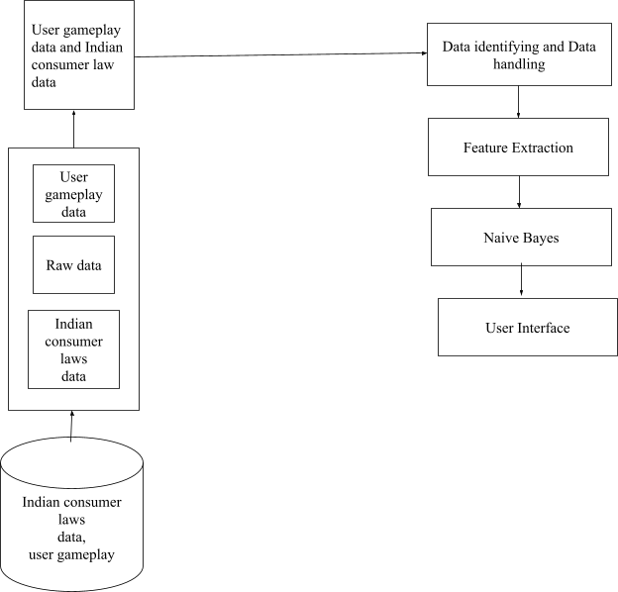

***Figure 3.1 System Architecture***

# PROCESS FLOW

The whole data collection procedure from many sources, including court records, consumer complaints, and case history, is the first step in the process flow of the gamified literacy analysis of Indian consumer policies. In order to make sure that this raw data is prepared for further examination, it is carefully preprocessed. After preprocessing, the data is divided into training and testing sets. Data modeling then takes place, using sophisticated machine learning techniques to create a custom

prediction model from the preprocessed data. After the model has been trained, it is used for predictive analysis, which allows insightful predictions to be made based on observed legal trends and patterns.In summary, User Gameplay Visualization facilitates the interactive presentation of these insights to users through the use of visual aids like charts and graphs. This approach increases user engagement and promotes a more profound comprehension of Indian consumer protection legislation.

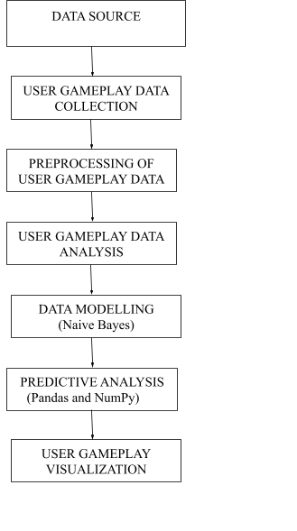

***Figure 3.2 Process Flow Diagram***

# DATA FLOW DIAGRAM

The below represented diagrams are the data flow diagrams which explains our work.

# DFD LEVEL 0

The level 0 data flow diagram summarizes a simple process from input to output and outlines the project's basic flow. Basically, user gaming data makes up the input data, and the output data is the finished product. The intermediate procedure entails a rigorous analysis and prediction process in which the user gameplay data is carefully inspected and evaluated in order to produce insightful analysis and forecasts. The project's basic structure is briefly summarized in this concise figure, which also shows how the analytical and predictive processes smoothly convert input into output.

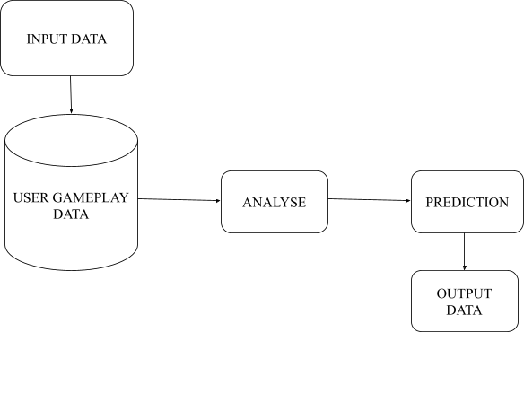

***Figure 3.3 DFD Level 0***

# DFD LEVEL 1

The key features of the system are described in detail in Figure 3.4. User interactions and gaming data are gathered and stored in the user gameplay database, which acts as the hub for user gameplay data collecting. After that, this data enters the preprocessing phase for preparation and organizing. After that, by eliminating discrepancies, the cleaning stage guarantees the quality of the data. User gameplay statistics are then generated by the extraction of information pertaining to consumer protection regulations through user gameplay analysis. A thorough understanding of user patterns and interactions is provided by these statistics. In the end, all of these phases contribute to the user's gameplay visualization, which provides a visually stimulating and easy-to-understand experience for users to better comprehend Indian consumer protection legislation. Forecasted insights and statistics are shown graphically.

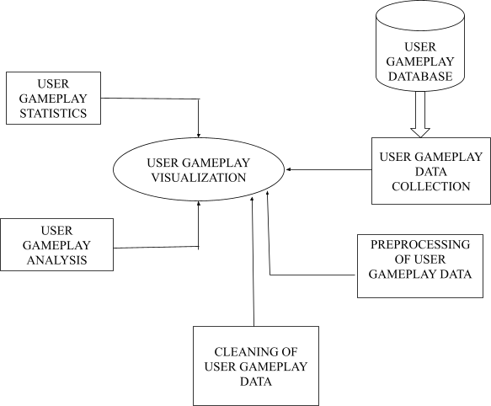

***Figure 3.4 DFD Level 1***

# DFD LEVEL 2

The DFD level 2 depicts the system's detailed data flow in Figure 3.5. There is a significant amount of raw data because all user and consumer law information is gathered from multiple sources. Many unclassified records make up this raw data, which needs to be organized and segmented in order to be effectively analyzed. Following classification, the unclassified raw data is divided into three separate categories: user, Indian consumer law, and user gameplay data. Together, these categorized datasets make up the first phase of the user gameplay data collection procedure. This methodical methodology guarantees that the system collects and arranges the required data efficiently, establishing the foundation for the preprocessing, analysis, and visualization phases that follow.

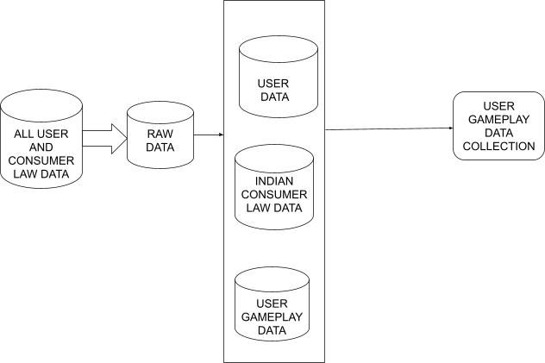

***Figure 3.5 DFD Level 2***

In DFD level 2, after user gameplay data collection, the next step is preprocessing of user gameplay data. Preprocessing of user gameplay data is a machine learning technique used to transform the raw data. In the below figure 3.6, the collected data contains all user and consumer law data with many missing and noisy values. Missing and noisy values are common problems in real-time data. The lost data can cause bias in the estimation of parameters and provide incorrect values, leading to poor efficiency of the model. These values should be removed to make the data suitable for analysis and prediction models.

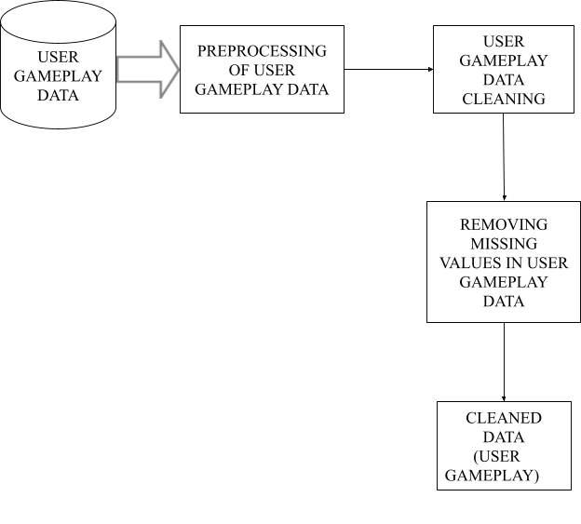

***Figure 3.6 DFD Level 2***

In DFD level 2, the below figure 3.7 shows the brief analysis of user gameplay analysis. It includes all the process till analysis. After the data is cleaned, we classify user gameplay data types according to their user data count values. Based on the analysis, we found that the user gameplay data is the highest among other users. So, a predictive analysis is made on it.

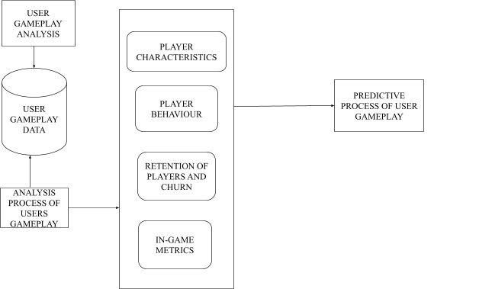

***Figure 3.7 DFD Level 2***

The system in DFD level 2, shown in Figure 3.8 above, uses gaming data analysis to forecast player attributes, displaying an organized procedure for handling this data. It describes how gameplay data is directed into two different processes: one is probably used to build a model using methods like Naive Bayes, while the other one group's player attributes. Next, data segmentation is made easier by a decision tree classifier, most likely for training and testing, which improves the accuracy and resilience of the model.Lastly, the system compares the data to the expected player attributes, probably using a range of metrics to gauge how well the model works. Although the DFD offers a high-level perspective, it is not detailed enough about particular algorithms or the complex data management in each process, thus there is need for more research and improvement in later phases of development.

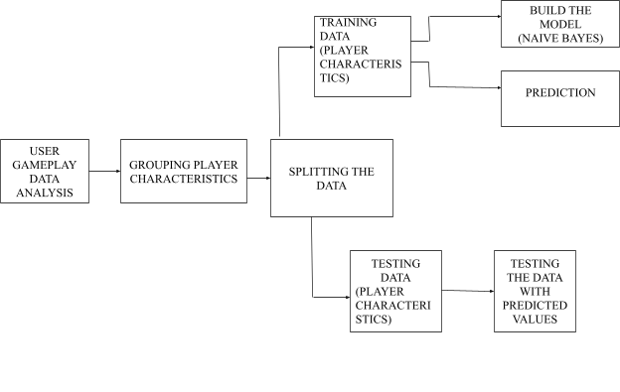

***Figure 3.8 DFD Level 2***

# UML DIAGRAMS

The following UML diagrams are required for the project, they are:

1. Use case diagram
2. Activity diagram
3. Class diagram

# USE CASE DIAGRAM

The gamified system of Indian Consumer Protection laws, the player is the main actor. The player interacts with various use cases including selecting game levels, avatars, solving puzzles, engaging in negative scenarios, and collecting points and rewards. They also learn about consumer laws, challenge friends, train a classifier to identify violations, generate quiz questions, and participate in quizzes specifically on Indian Consumer Protection laws. Additionally, the player can run the game, view their progress on the dashboard, and trigger quiz sessions to test their knowledge.

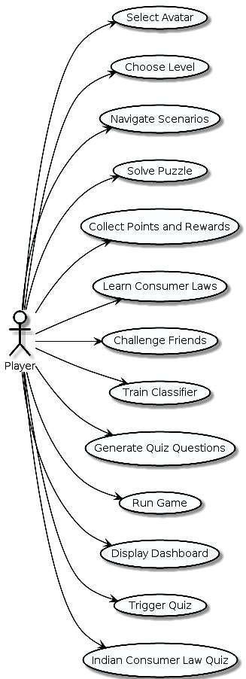

***Figure 3.9 USE CASE DIAGRAM***

# ACTIVITY DIAGRAM

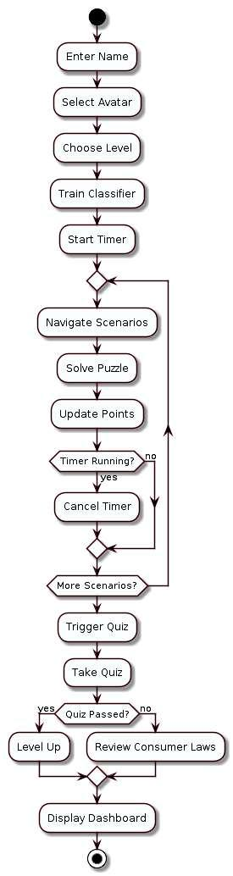

***Figure 3.10 Activity diagram***

Activity diagram is a flowchart to represent the flow from one activity to another activity as shown in figure 3.10. The activity diagram outlines the flow of a scenario-based game designed to educate players about consumer protection laws. The game starts with the player entering their name and selecting a scenario. Following this, they choose a difficulty level within the scenario and navigate through it, likely making decisions or completing tasks to advance the story. Along the way, they encounter puzzles that require solving, and their points are updated based on their performance. The system checks for an active timer; if present, it continues; otherwise, the timer is canceled. After completing a scenario, the system determines if more scenarios are available. If so, the player can choose another level or scenario; otherwise, the game progresses. A quiz is then triggered, testing the player's knowledge from the scenarios. Depending on their performance, they either level up or move forward. To reinforce learning, players review relevant consumer laws after the quiz. Finally, the game displays a dashboard showing their progress and achievements. In essence, the game offers an engaging journey where players solve puzzles, take quizzes, and gain insights into consumer laws through various scenarios and levels.

# CLASS DIAGRAM

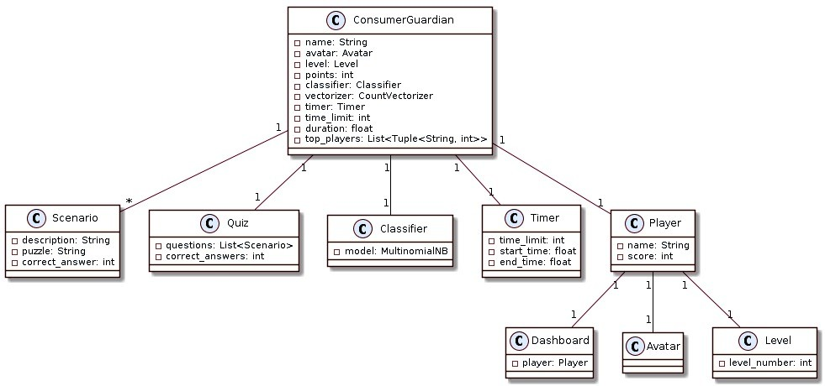

***Figure 3.11 Class diagram***

A "Scenario," which presents obstacles, opens the game. To score points, players must follow narratives and finish puzzles within the allotted time. Active timers stop after a scenario is finished, and fresh situations are looked for. If none, a quiz assesses player understanding and determines whether information on consumer law has advanced or needs to be reviewed. A dashboard displays achievements after the game. Different classes control player progression, time, and modeling, including Classifier, Timer, and Player.

# SEQUENCE DIAGRAM

It shows the interactions between the Player, ConsumerGuardian class, Scenario, Classifier, Timer, and Quiz classes. Here's a breakdown of the interactions:

**Start Game:** The player starts the game by calling the startGame() method on the ConsumerGuardian class.

**Select Avatar:** The ConsumerGuardian class calls the selectAvatar() method, likely prompting the player to choose an avatar for the game.

**Choose Level**: The ConsumerGuardian class calls the chooseLevel() method, likely presenting the player with options to select a level within the game.

**Train Classifier:** The trainClassifier() method in the ConsumerGuardian class likely trains a machine learning model for assessing player performance.

**Start Timer:** The ConsumerGuardian class calls the startTimer() method on the Timer class, initiating a timer for the current scenario or level.

**Loop:** The diagram shows a loop that iterates for each scenario in the game.

**Get Scenario:** Inside the loop, the ConsumerGuardian class calls the getScenario() method, likely to retrieve information about the current scenario.

**Update Points:** The ConsumerGuardian class calls the updatePoints() method, likely to update the player's score based on their performance in the puzzles.

**Check Timer:** The ConsumerGuardian class calls the checkTimer() method on the Timer class, likely to check if the timer for the current scenario or level has expired.

**Return Quiz Results:** The Quiz class returns the quiz results to the ConsumerGuardian class.

**Display Dashboard:** The ConsumerGuardian class calls the displayDashboard() method, likely to show the player their game progress or achievements.Overall, the sequence diagram shows how the player interacts with the Consumer Guardian game, selecting an avatar, progressing through scenarios, solving puzzles, taking quizzes, and receiving feedback on their performance

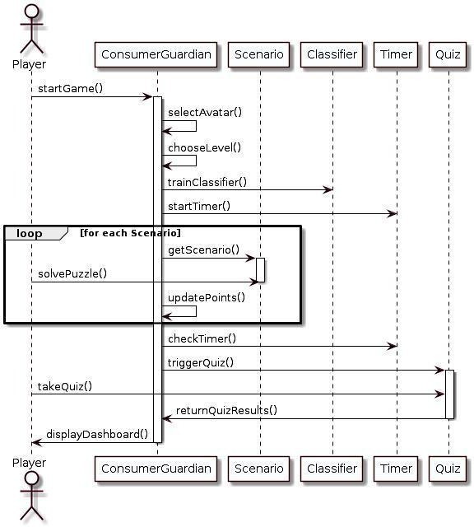

***Figure 3.12 Sequence diagram***

# SUMMARY

Carefully designed for both learning and interaction, the system design incorporates gamification concepts to guide players through various stages or situations related to Indian Consumer Protection regulations. Through a series of interactive tasks such as law reviews, quizzes, and puzzles, players are taken on a progressive educational trip that covers everything from basic principles to complex legislation. Using machine learning and predictive analysis, the system can intelligently customize each player's learning path and provide individualized content based on their success.The system utilizes gamification concepts to provide users with a personalized and captivating learning experience by guiding them through interactive tasks related to Indian Consumer Protection regulations.

# CHAPTER-4 SYSTEM IMPLEMENTATION

* 1. **INTRODUCTION**

The combination of game production and quiz integration is a cutting edge method of education that provides an engaging way to teach students about Indian consumer laws. Players interact with real-world settings through realistic games, learning about the nuances of consumer rights and duties firsthand. Integrated quizzes enhance the interactive experience by offering chances for evaluation and reinforcement, which promotes engagement and long-term learning. Through the integration of pleasure and instruction, this innovative method not only improves understanding but also cultivates a more profound respect for legal structures. In the end, it gives people the ability to decide for themselves as advocates and customers, which helps create a more fair market in India.Furthermore, this creative educational project responds to the urgent need for approachable and interesting legal literacy strategies, especially in light of the quickly changing consumer environment. The project transcends geographic and socioeconomic barriers to reach a diversified audience that includes students, consumers, and policymakers by leveraging the enormous popularity of gaming and the accessibility of digital platforms. Its all-inclusive strategy encourages a culture of knowledgeable consumption, enabling people to confidently and clearly negotiate the complexity of the market. As a result, the project promotes a more just and knowledgeable society overall in addition to enhancing individual empowerment.

# NAIVE BAYES ALGORITHM INTEGRATION

The procedure for integrating the Naive Bayes algorithm into the game system to adjust quiz difficulty levels in response to player performance and advancement is covered in great length in this subsection. It begins by summarizing the overall goal and reasoning for using Naive Bayes, highlighting its appropriateness for dynamically changing quiz questions. The segment then explores the key phases of the integration process, such as feature selection, model training, data

preprocessing, and quiz difficulty modification. It clarifies how the algorithm uses player data analysis to forecast the best quiz difficulties, guaranteeing a flexible and interesting experience for each player.It also emphasizes how important it is to set up a feedback loop so that the algorithm can continuously improve its predictions by taking player feedback and performance data into account. The subchapter offers a thorough knowledge of how Naive Bayes improves quizzing, player engagement, and learning outcomes in the context of games through this in-depth exposition. The system uses the Naive Bayes model to examine past quiz results at the beginning of a session in order to ascertain the probability distribution of various question kinds and right answers.The chapter also explores the technical details of integrating the Naive Bayes algorithm into the game system, offering comprehensive insights into its use and operation. It clarifies the several factors and parameters that make up the algorithm's structure, including priors, likelihoods, and posterior probabilities, providing insight into the fundamental principles that underlie changes in quiz difficulty. The section also addresses the algorithm's iterative nature, highlighting the significance of ongoing improvement via feedback loops and adaptive learning techniques. The technology automatically adjusts quiz difficulty levels by repeatedly assessing player performance data and adding user feedback, guaranteeing a unique and captivating experience for every participant.Additionally, the article addresses potential difficulties and suggests optimization techniques to improve computing speed while highlighting the importance of efficiency and scalability in algorithm implementation. All things considered, this thorough explanation offers a comprehensive grasp of how the Naive Bayes algorithm transforms quiz integration within the game system, maximizing learning results and player engagement through data-driven adaptation and personalization.

# OVERVIEW OF THE PYGAME

Creating interactive and captivating experiences with games is made possible by the Pygame framework, which is especially useful when integrating quizzes into game creation. Pygame is a collection of Python modules made especially for creating video games, which makes it the perfect option for adding tests to a gaming environment. In this context, an introduction to Pygame would explain its features and how it helps with quiz integration. It would go over basic things like

launching the game, interpreting user input, displaying text and visuals, controlling game states, and putting game logic into practice. With Pygame, developers can manage user interactions with ease, construct visually appealing quiz layouts, and create intuitive quiz user interfaces.Furthermore, Pygame's adaptability makes it simple to integrate with other Python modules and libraries, giving developers the ability to add complex elements to quiz-based games like animation, sound effects, and score tracking. Ultimately, the introduction to Pygame would emphasize how important it is for streamlining the process of creating games and improving gameplay overall by integrating quizzes seamlessly.Additionally, Pygame's rich documentation and vibrant community support offer tools and guidance to developers at every stage of the game development process, guaranteeing seamless implementation and debugging. Because of its cross-platform compatibility, games can be made that work on a variety of hardware and operating systems, increasing accessibility for a larger audience. All things considered, Pygame is a strong and flexible platform for incorporating tests into game development, giving programmers the freedom and features they need to create captivating and immersive gaming environments.

# CUSTOMIZING NAIVE BAYES DIFFICULTY LEVELS

The process of tailoring Naive Bayes difficulty levels includes using the Naive Bayes algorithm to dynamically modify quiz questions according to the performance and advancement of each individual player. To get ready for entering the data into the algorithm, preparation of the gathered player data—such as quiz results, reaction times, and completion rates—begins the process. From this data, relevant features—like quiz scores and answer times—are chosen to act as input variables for the Naive Bayes model. The model can forecast each player's suitable quiz difficulty level after it has been trained on the preprocessed data. Based on the player's performance indicators, this prediction is made by an algorithm that continuously assesses and modifies the next question's difficulty to deliver the ideal amount of challenge.For example, if a player performs well on a regular basis, the difficulty level can go up to keep them interested and provide them a bigger challenge. On the other hand, if a player finds some questions challenging, the level of difficulty can drop to provide easier assignments. Player feedback and performance data are used to update the Naive Bayes model iteratively, creating a

feedback loop that gradually improves the customisation process. By dynamically adjusting to the player's ability level, this iterative strategy guarantees that the algorithm's predictions grow more precise and customized to each player's abilities, improving the overall learning experience.Furthermore, the procedure emphasizes how crucial it is to guarantee inclusivity and fairness in quiz design by adjusting difficulty levels to suit participants with different learning styles and ability levels. Additionally, the algorithm's iterative refining through continuous feedback loops emphasizes a dedication to constant optimization and development, representing a flexible and adaptable approach to instructional game design.Additionally, the procedure not only improves each player's learning experience on an individual basis but also gives them a sense of empowerment and control because they can see their success mirrored in the quizzes changing difficulty levels. The system fosters a growth mentality by adjusting the difficulty level to correspond with each player's competency and skill development, encouraging resilience and tenacity in the face of progressively difficult tasks. In addition to increasing engagement, this flexible method of quiz customization fosters a stronger sense of personal responsibility for one's educational path. Additionally, the algorithmic adjustment's iterative nature highlights a dedication to innovation and constant development, which is consistent with the dynamic nature of educational technology.

# COMBINING THE NAIVE BAYES ALGORITHM WITH QUIZZES

Quizzes are personalized and adaptive, adapting question selection based on player performance and preferences by utilizing the Naive Bayes algorithm. The system dynamically modifies question difficulty as players advance by analyzing historical quiz data to predict question kinds and response probabilities. As a result of ongoing input, the algorithm becomes more and more adept at customizing quiz content, which boosts retention, engagement, and skill improvement.Players are constantly pushed at the right level thanks to this individualized approach, which promotes a more interesting and productive learning environment. Through real-time dynamic adjustment of question complexity, the system sustains player interest and encourages ongoing skill growth. Furthermore, with time, the Naive Bayes algorithm's iterative refinement improves both its accuracy and adaptability, resulting in more accurate and pertinent quiz personalization. In the end, the incorporation of the Naive Bayes algorithm into quizzes is a noteworthy

development in educational gaming, providing customized learning experiences that accommodate personal tastes and demands.Furthermore, the application of the Naive Bayes algorithm not only improves quiz personalization effectiveness but also advances our knowledge of unique learning styles and preferences. Targeted interventions and support mechanisms can be made easier by the system's analysis of player performance metrics and response probabilities, which provides insights into cognitive processes and knowledge acquisition tactics. This data-driven strategy guides the creation of future educational content and interventions while also optimizing learning outcomes and informing instructional design tactics. Additionally, the algorithm's scalability and versatility guarantee that it can be applied to a wide range of learning environments and topic areas, highlighting its promise as a flexible tool for educational game production.

# SUMMARY

To ensure the smooth integration of interactive gaming components with educational content, the project's initial focus is on concept creation and technology selection. Pygame is a well-liked framework for creating entertaining games in Python that is selected due to its adaptability and simplicity of usage. Simultaneously, the Naive Bayes algorithm's inclusion highlights a dedication to customized learning and adaptive difficulty modification, allowing the game to dynamically change challenges to each player's skill level.

As the quiz phase progresses, close consideration is paid to question selection, interface design, and module integration in order to produce a seamless and engaging learning environment.Smooth navigation and interaction are made possible by the interface's thoughtful design, which is easy to use and intuitive. A meticulous selection process guarantees that the quiz questions are pertinent and in line with the main ideas of Indian consumer regulations, encouraging significant participation and retention of information.

A continuous feedback loop is set up at both phases of development to collect user comments and improve the course materials in response to current user preferences and real-time insights. By using an iterative process, the instructional material is kept up to date with the changing demands and expectations of the player base, which improves its efficacy and applicability over time.

# CHAPTER 5 TESTING

Testing is essential in the development of a gamified literacy analysis of Indian Consumer Protection Laws. The system comprises three main modules: Consumer Rights and Responsibilities, Legal Framework and Case Studies, and Gamified Quizzes and Challenges. The first module educates users on consumer rights and responsibilities, while the second delves into the legal aspects through laws and case studies. The third module offers interactive quizzes and challenges to reinforce learning. Sequentially integrated, these modules aim to educate consumers about their rights in an engaging manner, empowering them to make informed decisions and navigate the complexities of consumer protection laws effectively.

# INTRODUCTION

The test cases have been successfully validated across the various modules of our proposed system, focusing on a gamified literacy analysis of Indian Consumer Protection Laws. The architecture of our system comprises three interdependent modules: Consumer Rights and Responsibilities, Legal Framework and Case Studies, and Gamified Quizzes and Challenges. Each module builds upon the knowledge gained from the previous one, showcasing a sequential workflow that ensures comprehensive understanding. If any part of our proposed system architecture falls short, it compromises the integrity and functionality of the entire system. Testing encompasses a variety of scenarios to ensure that the system aligns with the proposed architecture while accommodating new features and data for enhanced user experience.

# TESTING THE GAMIFIED MODEL

The evaluation of the gamified model encompasses a multifaceted approach to ensure comprehensive assessment of its functionality, engagement, and educational effectiveness.

# USER ENGAGEMENT METRICS

We analyze user interaction patterns, time spent on the platform, and frequency of returning users. These metrics help us understand the level of engagement and

interest the gamified modules generate among users. A higher engagement rate indicates the effectiveness of the gamified approach in capturing and maintaining user attention.

# QUIZ AND CHALLENGE COMPLETION RATES

Completion rates for quizzes and challenges within the gamified modules are tracked to measure user participation and progression. High completion rates suggest that the gamified content is engaging and motivating users to complete tasks, reinforcing their learning about consumer protection laws.

# USER FEEDBACK AND SATISFACTION SURVEYS

We gather qualitative data through user feedback forms and satisfaction surveys. Users are asked to provide insights into their experience with the gamified modules, including what they found most engaging, areas of improvement, and the overall value they derived from the learning experience.

# TEST CASES

Test cases are rigorously designed to evaluate functionality, accuracy, and user engagement across modules. Each case is structured with a unique identifier, scenario, and expected outcomes, covering content accuracy, user engagement in quizzes, challenges, and overall experience. Results, statuses, and remarks are meticulously recorded for transparency and improvement guidance, facilitating effective, accurate, and engaging learning experiences.

# MODULE-1 CONSUMER RIGHTS AND RESPONSIBILITIES

In Module-1, "Consumer Rights and Responsibilities," test cases are designed to rigorously evaluate the accuracy, clarity, and user engagement of the content presented. The test cases cover various aspects, including detailed consumer rights information, responsibilities, and legal obligations. Each test case focuses on specific sections or topics within the module to ensure thorough coverage.

Results for each test case are recorded with a clear status indicating pass or fail, along with brief remarks providing insights into the testing process. The evaluation assesses not only the factual accuracy of the content but also its relevance and effectiveness in educating users about their consumer rights and responsibilities. This comprehensive testing approach ensures that Module-1 delivers accurate,

informative, and engaging content that effectively educates users on consumer protection laws.

|  |  |  |  |  |  |
| --- | --- | --- | --- | --- | --- |
| TC ID | SCENARIO | SECONDARY CONSIDERA- TIONS | EXPECTED OUTPUT | STATUS | REMARKS |
| TC01 | Load consumer rights content | Content is comprehensive and up-to-date | All consumer rights data are loaded | Pass | Comprehen sive coverage of consumer rights |
| TC02 | Verify legal accuracy | Check for legal accuracy and updates | Accurate legal content | Pass | Content is legally accurate and updated |
| TCO3 | Clarity of content presentation | Ensure clarity and understandabili ty | Clear and understand- able content | Pass | Content is clear and easy to understand |
| TC04 | Relevance to user needs | Content relevance to consumer needs and rights | Relevant consumer information | Pass | Content is highly relevant to users' rights |
| TC05 | Engagement level of content | Evaluate user engagement and interaction | High engagement metrics | Pass | Content engages and holds user interest |

***Table 5.1 test case for module-1 Consumer Rights and Responsibilities***

# MODULE-2: LEGAL FRAMEWORK AND CASE STUDIES

In Module-2, "Legal Framework and Case Studies," the test cases are designed to evaluate the depth, relevance, and clarity of the legal content presented, as well as the effectiveness of the case studies in illustrating key legal principles. The test cases cover various legal concepts, statutes, and case studies related to Indian Consumer Protection Laws.

Each test case assesses specific sections or topics within the module, such as the explanation of legal terms, interpretation of consumer protection laws, and the relevance of case studies to real-world scenarios. The goal is to ensure that the module provides a comprehensive understanding of the legal framework governing consumer rights in India and demonstrates how these laws are applied through practical case studies.

Results for each test case are meticulously recorded with a clear status indicating pass or fail, accompanied by brief remarks offering insights into the evaluation process. This detailed testing approach ensures that Module-2 not only presents accurate and relevant legal information but also effectively educates users on how to apply this knowledge in real-life situations.

|  |  |  |  |  |  |
| --- | --- | --- | --- | --- | --- |
| TC ID | SCENARIO | SECONDARY CONSIDERA- TIONS | EXPECTED OUTPUT | STATUS | REMARKS |
| TC06 | Load legal content | Comprehensive coverage of Indian Consumer Laws | All legal content is loaded | Pass | Comprehen sive legal coverage loaded |
| TC07 | Verify legal terms accuracy | Accuracy of legal terms used | Legal terms correctly presented | Pass | All legal terms are accurate and well- defined |

|  |  |  |  |  |  |
| --- | --- | --- | --- | --- | --- |
| TCO8 | Clarity of legal content | Clarity and understandabili ty of legal descriptions | Clear and understanda ble legal content | Pass | Legal content is clear and easy to comprehen d |
| TC09 | Relevance of case studies | Relevance to real-world scenarios | Case studies align with real scenarios | Pass | Case studies are relevant and effectively presented |
| TC10 | Applications of legal principles | Effectiveness in illustrating legal principles | Effective demonstrati on of principles | Pass | Legal principles are effectively illustrated |

***Table 5.2 test case for module-2 Legal Framework and Case Studies***

# MODULE-3: GAMIFIED QUIZZES AND CHALLENGES

In Module-3, "Gamified Quizzes and Challenges," the test cases focus on evaluating the functionality, relevance, and engagement level of the quizzes and challenges integrated into the gamified learning experience. The objective is to assess how effectively these interactive elements reinforce learning objectives and maintain user interest.

Each test case examines specific aspects of the gamified quizzes and challenges, such as question quality, relevance to the content, user interface design, and feedback mechanisms. The test cases also evaluate the difficulty level, pacing, and variety of challenges to ensure they cater to users with different levels of knowledge and expertise.

Results for each test case are recorded with a clear status indicating pass or fail, along with brief remarks providing insights into the evaluation process.

This comprehensive testing approach ensures that Module-3 offers engaging, interactive, and educational quizzes and challenges that effectively reinforce the knowledge gained from the previous modules and encourage continued learning and engagement.

|  |  |  |  |  |  |
| --- | --- | --- | --- | --- | --- |
| TC ID | SCENARIO | SECONDARY CONSIDERA- TIONS | EXPECTED OUTPUT | STATUS | REMARKS |
| TC11 | Quality of Questions | Relevance to the content | Questions evaluated | Pass | Questions align well with module content |
| TC12 | User interface design | Ease of use, visual appeal | UI  functionality test | Pass | Interface is user-friendl y and visually appealing |
| TC13 | Feedback Mechanisms | Timeliness and relevance of feedback | Feedback effectivenes s | Pass | Feedback is timely and relevant |
| TC14 | Difficulty Level | Suitability for various knowledge levels | Challenge appropriaten ess | Pass | Difficulty is well-suited for all users |
| TC15 | Pacing of Challenges | Consistency and progression pacing | Pacing evaluation | Pass | Pacing maintains engagement throughout |

***Table 5.3 test case for module-3 Gamified Quizzes and Challenges***

# MODULES TESTED

* + - 1. Consumer Rights and Responsibilities
      2. Legal Framework and Case Studies
      3. Gamified Quizzes and Challenges

Each module encompasses specific sub-modules to ensure a comprehensive and engaging learning experience.

# Module 1 - Consumer Rights and Responsibilities

This module focuses on educating users about their consumer rights and responsibilities. The test cases verify the accuracy and relevance of the information presented, including:

1. Understanding of Consumer Rights
2. Responsibilities towards Consumers
3. Legal Obligations and Protections

# Module 2 - Legal Framework and Case Studies

The second module delves into the legal aspects of consumer protection laws in India. Test cases assess the depth and clarity of legal content, as well as the effectiveness of case studies in illustrating legal principles. Sub-modules and test cases include:

1. Overview of Consumer Protection Laws
2. Key Legal Terms and Definitions
3. Relevance of Case Studies to Real-world Scenarios

# Module 3 - Gamified Quizzes and Challenges

Module-3 focuses on reinforcing learning through interactive quizzes and challenges. Test cases evaluate the functionality, relevance, and engagement level of these gamified elements. Sub-modules and test cases cover:

1. Quiz Questions aligned with Learning Objectives
2. Challenge Levels and Pacing
3. User Engagement and Feedback Mechanisms

Results for each module's test cases are recorded with clear statuses (pass/fail) and detailed remarks. This structured testing approach ensures that the "Gamified Literacy Analysis of Indian Consumer Protection Laws" delivers an effective, accurate, and engaging educational experience for users.

# SUMMARY

The three primary sections of the learning site are the legal framework with case studies, gamified tasks and quizzes, and consumer rights and obligations. Extensive testing ensures correctness, relevance, and user engagement by confirming case study efficacy, content clarity, and interactive element operation. The outcomes underwent a thorough analysis to pinpoint areas in need of improvement.The first module provides an overview of consumer rights and obligations by going over key ideas and ideas. In Module 2, the legal foundation for consumer protection laws is explored in greater detail. Important concepts are emphasized through the use of real-world case studies. To sum up, Module 3 incorporates gamified components like challenges and quizzes to improve user engagement and reinforce learning. By means of extensive testing, the platform guarantees that the content is comprehensible, educational, and efficiently conveyed, cultivating among users a thorough comprehension of Indian consumer protection legislation.The platform puts an emphasis on user participation and interaction, providing a dynamic learning environment that goes beyond conventional techniques. Users actively engage in the learning process, strengthening their comprehension of legal topics and consumer rights through interactive challenges and quizzes. Accessibility is further improved by the platform's user-friendly interface, which makes it simple for users to move between modules and find pertinent information.Additionally, users will receive content that is specifically tailored to them based on their performance and progress according to the platform's adaptive learning strategy, which maximizes the value of the educational experience. The platform is kept up to date and relevant by regular upgrades and enhancements based on user feedback, which address changing legal environments and customer needs. The platform upholds a high quality of accuracy and comprehensiveness by partnership with legal experts and educators, thereby providing users with trust regarding the reliability of the material offered. In the end, the platform is a useful tool for anyone trying to understand the intricacies of India's consumer protection regulations.The platform puts an emphasis on user participation and interaction, providing a dynamic learning environment that goes beyond conventional techniques.

# CHAPTER-6 EXPERIMENTAL ANALYSIS

* 1. **INTRODUCTION**

This chapter delves into the analysis of player engagement and learning effectiveness within the gamified literary analysis project, exploring factors such as player statistics, interaction types, game location, and quiz performance. By leveraging gamified analysis techniques, the chapter aims to illuminate the current state of player engagement and learning outcomes within the game environment. Through an in-depth examination of player interactions and educational effectiveness, insights are gained into the efficacy of gamified approaches in promoting understanding and awareness of Indian consumer laws. Additionally, the chapter assesses the potential societal impact of the project, highlighting opportunities for significant change through enhanced education and awareness. Overall, this analysis provides valuable insights for refining the gamified literacy analysis project and maximizing its effectiveness in educating and empowering players regarding consumer laws.

# ANALYSIS

The integration of the Naive Bayes algorithm in the game development phase signifies a data-driven approach to enhance player experience. By dynamically adjusting game difficulty based on player performance, the game offers personalized challenges, optimizing engagement and learning outcomes. The capture and analysis of player data further contribute to this personalized experience, allowing for tailored recommendationp[s and feedback. Additionally, the implementation of a testing and training system reflects a commitment to continuous improvement, ensuring that the game remains relevant and effective in educating players about Indian consumer laws.

In the quiz integration phase, the incorporation of an Indian consumer law quiz serves as a valuable assessment tool to evaluate players' understanding of key concepts. The development of a quiz module with relevant questions and a comprehensive database underscores the commitment to delivering accurate and informative content.

Extensive testing for accuracy and educational effectiveness highlights a dedication to quality assurance, ensuring that players receive valuable learning experiences. Moreover, the emphasis on continuous updates based on user feedback demonstrates a responsiveness to player needs and preferences, enhancing the overall educational impact of the quiz within the game.

Overall, the analysis underscores the strategic approach taken in both the game development and quiz integration phases to create an engaging and educational experience for players. By leveraging data-driven insights, personalized experiences, and continuous improvement efforts, the project aims to effectively educate players about Indian consumer laws while maximizing engagement and learning outcomes.

# PLAYER ENGAGEMENT METRICS

In this section, a comprehensive analysis is conducted to understand the depth and breadth of player engagement within the game environment. Various metrics are examined to provide a holistic view of player interaction and involvement. This includes not only quantitative data such as the total time spent playing the game and the frequency of logins but also qualitative aspects such as player feedback and satisfaction levels. Additionally, the completion rates of different game modules and the extent of interaction with various educational elements are evaluated to gauge the level of player engagement with the Indian consumer laws content. By delving into these engagement metrics, the project aims to gain valuable insights into the effectiveness of the game in capturing and maintaining players' attention and interest throughout their gaming experience.

# GAME PERFORMANCE ANALYSIS

This section focuses on analyzing the performance of the game in terms of its functionality, user experience, and educational effectiveness. It includes assessing factors such as game stability, loading times, responsiveness, and overall user satisfaction. Additionally, the educational impact of the game is evaluated, considering factors such as the clarity of information presented, the effectiveness of game mechanics in reinforcing learning objectives, and the overall engagement level of players with the educational content about Indian consumer laws.

Through this analysis, insights are gained into areas of strength and areas for improvement in the game's performance and educational value.

# Game Performance Analysis

* + - 1. Functionality
         * Stability
         * Loading Times
         * Responsiveness
      2. User Experience
         * User Satisfaction
         * Interface Design
      3. Educational Effectiveness
         * Clarity of Information
         * Learning Objectives Reinforcement
         * Engagement with Content

# LEARNING PROGRESS TRACKING

This section focuses on monitoring and analyzing the progress of players' learning within the game environment. It involves tracking various indicators of learning, such as quiz scores, completion of educational modules, and the application of learned concepts in gameplay. Additionally, player feedback and interactions with learning materials are considered to gain insights into their understanding and retention of Indian consumer laws. Through this analysis, the project aims to evaluate the effectiveness of the game in facilitating learning outcomes and identify areas for further improvement in educational content and delivery.

# GAME DIFFICULTY ADJUSTMENT

This section describes how the Naive Bayes algorithm is used to dynamically change the game's complexity according to how well players perform. The Naive Bayes algorithm is used to evaluate a number of variables, including player interactions, quiz scores, and game module completion rates, in order to determine the player's ability level and modify the game appropriately. Using this algorithm, the game can provide each player a unique, difficult experience that maximizes engagement and learning results.Furthermore, the adaptive nature of the algorithm guarantees that the game stays lucrative and challenging, which maximizes player motivation and happiness throughout the course of their gaming experience.The Naive Bayes algorithm makes constant adjustments to the game's complexity based on player data analysis, so players are always faced with challenges that are

appropriate for their skill level. By avoiding activities that are either too simple or too difficult, this individualized approach not only reduces irritation but also helps players feel like they are making progress. Furthermore, the algorithm's flexibility allows the game to change as the player does, providing a dynamic and captivating experience that promotes continuous involvement. Players are therefore more likely to stay involved in the game, which promotes sustained enjoyment and improved learning results.

# PLAYER DATA ANALYSIS

* + 1. **CAPTURING AND ANALYZING PLAYER INTERACTIONS**

This section focuses on the process of capturing and analyzing player interactions within the game environment. It includes methods for collecting data on player actions, such as navigation patterns, clicks, and in-game decisions. Additionally, techniques for analyzing this data to gain insights into player behavior, preferences, and engagement levels are discussed. By understanding player interactions, the project aims to optimize game design, mechanics, and educational content to enhance player experiences and learning outcomes.

# PERSONALIZED LEARNING EXPERIENCES

In this subsection, the project explores strategies for providing personalized learning experiences based on the analysis of player data. This involves tailoring game content, challenges, and feedback to match individual player preferences, skill levels, and learning styles. By leveraging insights from player interactions and performance metrics, the project aims to deliver targeted educational content that maximizes engagement and facilitates meaningful learning experiences for each player.

# TESTING AND IMPROVEMENT

* + 1. **EVALUATION OF QUIZ EFFECTIVENESS**

This section focuses on evaluating the effectiveness of the quiz module in assessing players' knowledge and reinforcing key concepts related to Indian consumer laws. It includes methods for measuring quiz performance metrics such as accuracy, completion rates, and player feedback. Additionally, techniques for identifying strengths and weaknesses in the quiz design and content are discussed. By evaluating quiz effectiveness, the project aims to refine the quiz module to

better meet educational objectives and enhance learning outcomes for players.By conducting a thorough examination of quiz performance measures, such as accuracy, completion rates, and player comments, the research seeks to obtain important knowledge about how well the quiz module reinforces important ideas associated with Indian consumer legislation. Through the utilization of these data, the project team may pinpoint areas in which the quiz's design and content require enhancement, guaranteeing that it is closely in line with instructional goals. Additionally, the initiative aims to improve players' overall learning outcomes by iteratively improving the quiz module in response to evaluation results, therefore optimizing the game's educational impact. The project's commitment to provide a top-notch educational experience that equips participants with important information of consumer rights and protections in India is highlighted by its iterative approach to evaluation and improvement.

# CONTINUOUS IMPROVEMENT STRATEGIES

In this subsection, the project explores strategies for continuously improving the game and quiz modules based on player feedback and performance data. This includes methods for collecting and analyzing user feedback, implementing iterative updates and enhancements, and monitoring the impact of changes on player engagement and learning outcomes. By adopting a data-driven approach to continuous improvement, the project aims to maintain relevance, effectiveness, and engagement over time.The initiative also highlights how crucial it is to have an open feedback loop with players, inviting them to express their opinions, ideas, and worries about the quiz modules as well as the game. Through proactive player feedback solicitation and careful listening, the project team can acquire essential insights into areas of strength and opportunity for growth. The project team may also iteratively improve the game and quiz modules to better suit players' changing requirements and expectations by closely observing the effects of modifications on player engagement and learning outcomes.

# SUMMARY AND CONCLUSION

This final section provides a comprehensive summary of key findings and insights from the player data analysis, testing, and improvement processes. It highlights the significance of personalized learning experiences, effective quiz evaluation, and continuous improvement strategies in enhancing player engagement and educational effectiveness within the game environment. Additionally, the section outlines future directions and opportunities for further refinement and innovation in the gamified literacy analysis project.

# CHAPTER-7 FUTURE WORKS

* 1. **INTRODUCTION**

The future work for this game development project aims to enhance various aspects of the game to create a more engaging and effective educational experience for players interested in Indian consumer laws. This includes advancing adaptive learning algorithms, expanding legal content coverage, implementing multiplayer features, incorporating gamified learning analytics, fostering community engagement, and establishing a continuous improvement feedback loop. By focusing on these areas, the project seeks to deepen player involvement, improve learning outcomes, and ensure the game remains relevant and valuable to its audience.

# ADVANCED ADAPTIVE LEARNING ALGORITHMS

* + 1. **RESEARCH AND IMPLEMENTATION**

**Exploration of Advanced Models:** Conduct in-depth research into advanced machine learning algorithms like reinforcement learning or deep learning models. Evaluate their applicability and effectiveness in enhancing the game's adaptive learning capabilities.

**Prototyping and Experimentation:** Develop prototypes to experiment with different algorithms. Test their performance in dynamically adjusting game difficulty based on player behavior, learning patterns, and performance metrics.

**Integration and Testing:** Once a suitable algorithm is identified, integrate it into the game framework. Conduct extensive testing to assess its effectiveness in providing personalized learning experiences. Evaluate factors such as accuracy, scalability, and computational efficiency.

# PERSONALIZATION ENHANCEMENT

**Learning Style Analysis:** Implement algorithms capable of analyzing player interactions and preferences to identify individual learning styles. This may involve assessing factors like preferred learning format (visual, auditory, kinesthetic), pace of learning, and preferred types of challenges.

**Tailored Feedback and Challenges:** Customize the game experience based on identified learning styles. Provide tailored feedback, hints, and challenges that align with each player's unique learning preferences. This could involve adjusting the difficulty level of questions, offering supplementary learning resources, or providing adaptive hints and prompts.

# EXPANSION OF LEGAL CONTENT

* + 1. **CONTENT DIVERSITY**

**Continuous Content Updates:** Establish a process for regularly updating the game's database of legal content. This includes incorporating new laws, regulations, and judicial precedents relevant to Indian consumer rights.

**Diversification of Topics:** Expand the scope of legal content to cover a broader range of consumer-related topics. This may include areas such as product warranties, e-commerce regulations, consumer protection agencies' roles and functions, and emerging legal trends in consumer rights.

# REGIONAL VARIATIONS

**Legal Research and Localization:** Conduct comprehensive research into regional variations of consumer laws across different states in India. Consider factors such as language, culture, and socio-economic dynamics that may influence legal interpretations and enforcement.

**Customized Content Modules:** Develop customized content modules tailored to specific regions. Incorporate relevant legal provisions, case studies, and practical examples that resonate with players from different geographical backgrounds. Ensure that the content accurately reflects the nuances of regional consumer laws.

# MULTIPLAYER AND COLLABORATIVE LEARNING

* + 1. **MULTIPLAYER INTEGRATION**

**Introduction of Multiplayer Features:** Incorporate multiplayer features into the game to enable collaborative learning experiences. This could include synchronous gameplay modes where players interact in real-time, such as competing in legal challenges or quizzes against each other.

**Facilitation of Collaboration:** Provide mechanisms for players to collaborate while playing the game. This could involve features like chat functionality or collaborative problem-solving tools to encourage communication and teamwork.

# TEAM-BASED CHALLENGES

**Design of Team-based Scenarios:** Develop scenarios within the game that require players to work together in teams to solve complex legal challenges. Each team member may possess unique skills or knowledge that contribute to the overall solution.

**Fostering Collaboration Skills:** Emphasize collaboration and communication skills by designing challenges that necessitate coordination, delegation, and effective teamwork. Encourage players to strategize and delegate tasks based on each team member's strengths.

# GAMIFIED LEARNING ANALYTICS

* + 1. **DATA-DRIVEN INSIGHTS**

**Development of Analytics Tools:** Create sophisticated analytics tools to collect and analyze player data generated during gameplay. These tools should be capable of processing large volumes of data and extracting actionable insights.

**Identification of Learning Patterns:** Analyze player performance data to identify common misconceptions or areas of difficulty in understanding consumer laws. Use statistical analysis and machine learning algorithms to By leveraging predictive modeling, you can anticipate potential stumbling blocks in comprehension and tailor educational interventions to address these specific areas, fostering more effective learning outcomes.uncover patterns and trends in player behavior.

# GAMIFICATION OF FEEDBACK:

* + - * In-game Rewards and Achievements: Implement a system of in-game rewards and achievements based on players' progress and performance.
      * This could include unlocking new levels, earning virtual badges, or receiving personalized feedback messages.
      * Encouragement of Continuous Learning: Use gamified feedback mechanisms to motivate players to engage in continuous learning and improvement. Provide incentives for mastering challenging legal concepts and overcoming obstacles within the game.

By elaborating on multiplayer integration and gamified learning analytics, you can create a more engaging and effective educational experience for players interested in Indian consumer laws. These features not only enhance collaboration and communication skills but also provide personalized feedback and incentives for continuous learning and improvement.

# COMMUNITY ENGAGEMENT AND USER-GENERATED CONTENT

* + 1. **COMMUNITY FORUMS**

**Establishment of Online Forums:** Create dedicated online forums or social media groups where players can engage with each other, discuss legal concepts featured in the game, and share tips and strategies for solving legal challenges.

**Facilitation of Collaboration:** Encourage collaboration among players by providing a platform for them to form study groups, seek assistance from more experienced players, and collectively tackle complex legal scenarios within the game.

# USER-GENERATED CONTENT

**Empowerment of Players:** Enable players to contribute their own legal scenarios, questions, and quizzes to the game. Provide tools and templates for players to create and submit content, fostering a sense of ownership and investment in the game's community.

**Quality Assurance Mechanisms:** Implement moderation and review processes to ensure the quality and accuracy of user-generated content.Integrate both automated algorithms and human moderators to create a robust system that efficiently filters out irrelevant or inappropriate content while preserving valuable contributions.

# CONTINUOUS IMPROVEMENT AND FEEDBACK LOOP

* + 1. **ITERATIVE DEVELOPMENT**

**Adoption of Iterative Development Approach:** Embrace an iterative development methodology, where new features and enhancements are introduced incrementally based on user feedback and analytics insights.

**Regular Release Cycles:** Implement regular release cycles to roll out updates and enhancements to the game. Each iteration should address specific feedback and prioritize improvements that enhance the overall user experience and educational value.

# USER FEEDBACK MECHANISMS

**Integration of Feedback Channels:** Incorporate user feedback mechanisms directly within the game interface, allowing players to submit suggestions, comments, and bug reports easily.

**Responsive Development Process:** Establish processes for collecting, analyzing, and acting upon user feedback in a timely manner. Prioritize issues based on severity and impact, and communicate transparently with the community about planned updates and fixes.

# SUMMARY

In summary, the future work plan for this game development project focuses on enhancing the educational experience for players interested in Indian consumer laws. The plan involves several key initiatives, including the advancement of adaptive learning algorithms to provide personalized learning experiences through research, experimentation, and integration. Additionally, efforts will be made to expand the game's legal content coverage by continuously updating content, diversifying topics, and incorporating regional variations. Multiplayer features and team-based challenges will be introduced to facilitate collaborative learning experiences among players. Furthermore, sophisticated analytics tools will be developed to derive actionable insights from player data, and feedback mechanisms will be gamified to encourage continuous learning and improvement. Enhancements to the user interface and experience will be put into place to maximize accessibility for a variety of audiences, including those with impairments.

# APPENDIX A SAMPLE SCREEN SHOTS

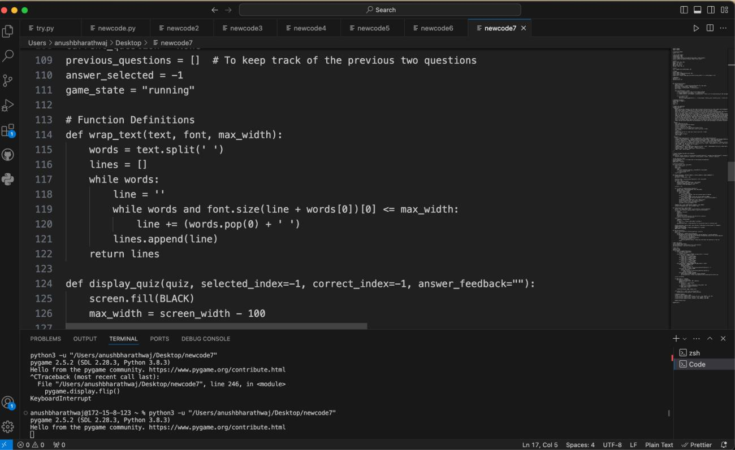

***Figure A1.1 Visual Studio Code***

Python code for a quiz game, including functions for text wrapping and displaying the quiz in Visual Studio Code.



***Figure A1.2 Sample Dataset***

Fig A1.2 depicts a dataset listing questions and options for a quiz on Indian consumer laws.

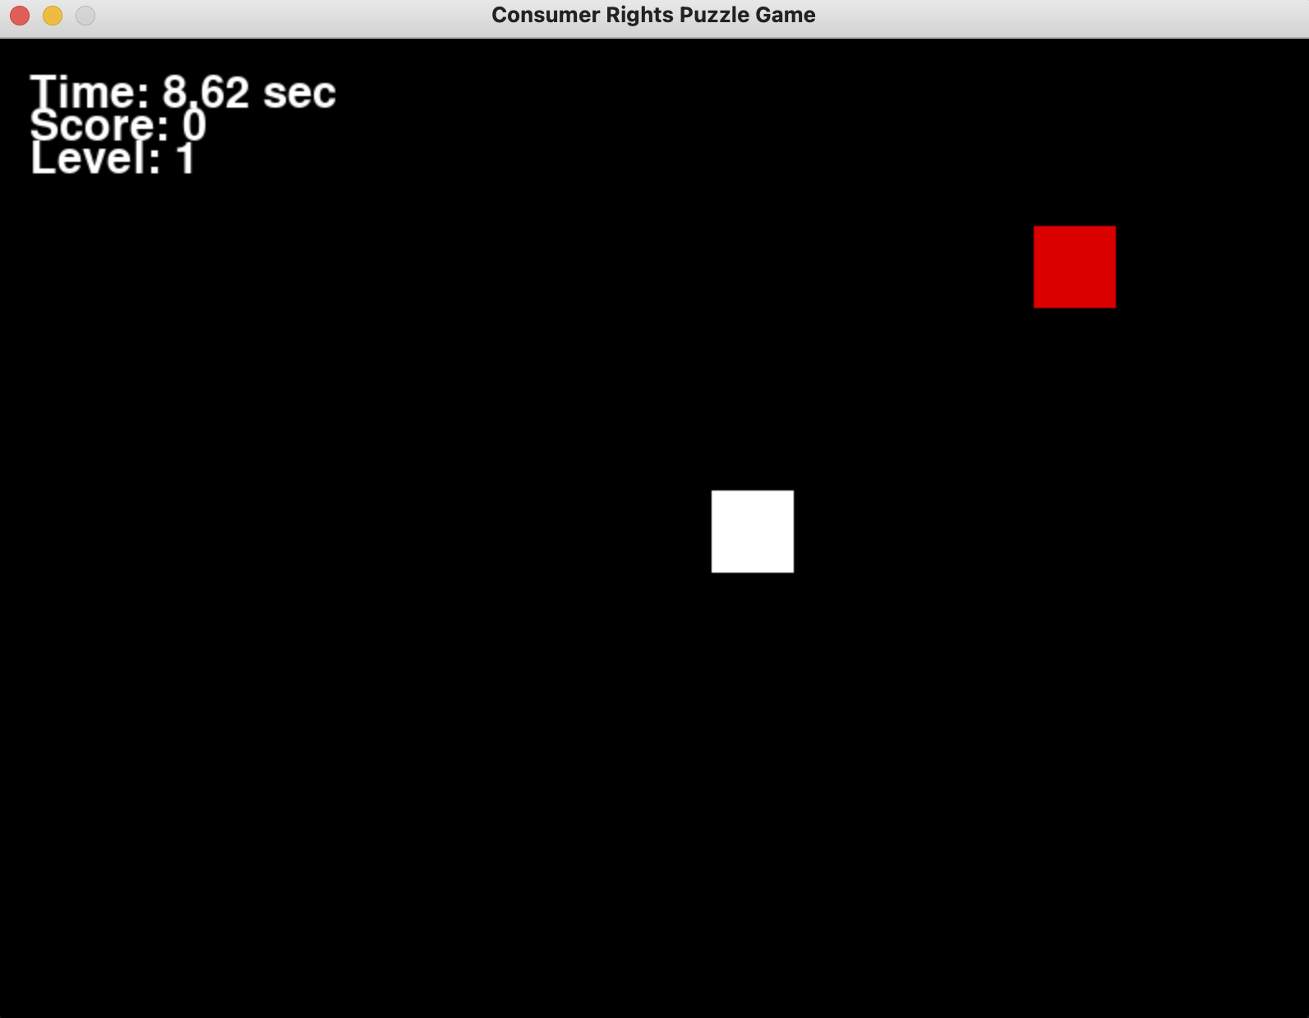

***Figure A1.3 Game Mode 1***

FIG A1.3 depicts a game scenario where a player controls a white box attempting to navigate through obstacles while avoiding a red box. If the white box collides with the red one, the game ends and the quiz will be displayed. The player's avatar is represented by the white box, which stands for their progress through the game's difficulties. An instructional element is added to the game by the incorporation of a quiz upon collision, which allows for a smooth transition between gameplay and educational opportunities.This integration not only adds an element of challenge but also encourages players to engage with educational content in an interactive manner. By seamlessly blending gameplay and learning, the game fosters a dynamic and enriching experience for players.

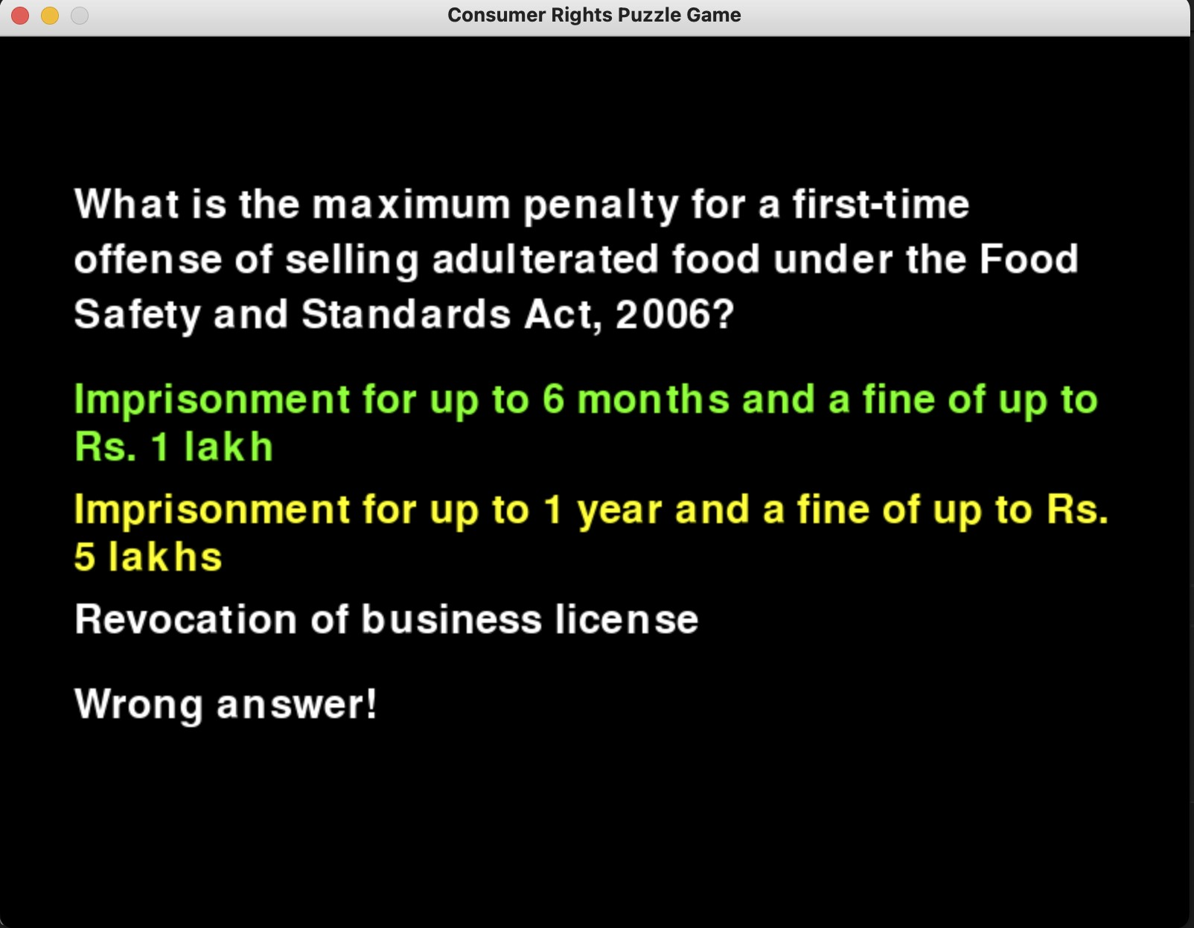

***Figure A1.4 Q&A Generation 1***

FIG A1.4 presents players with quiz questions where giving the wrong answer prevents you from moving forward, making the game harder. The gameplay is elevated by this blend of trivia and action, necessitating a balance between knowledge and skill to succeed. It is expected that the questions would cover a wide range of aspects related to consumer regulations in India, which will enhance the intricacy and appeal of the game. The quiz's interactive format serves as a means of both reinforcing important concepts and testing players' comprehension. Accurate answers have the potential to open doors to other stages, rewarding players for their understanding. Player engagement and learning are enhanced by the smooth transition between instructional content and games.

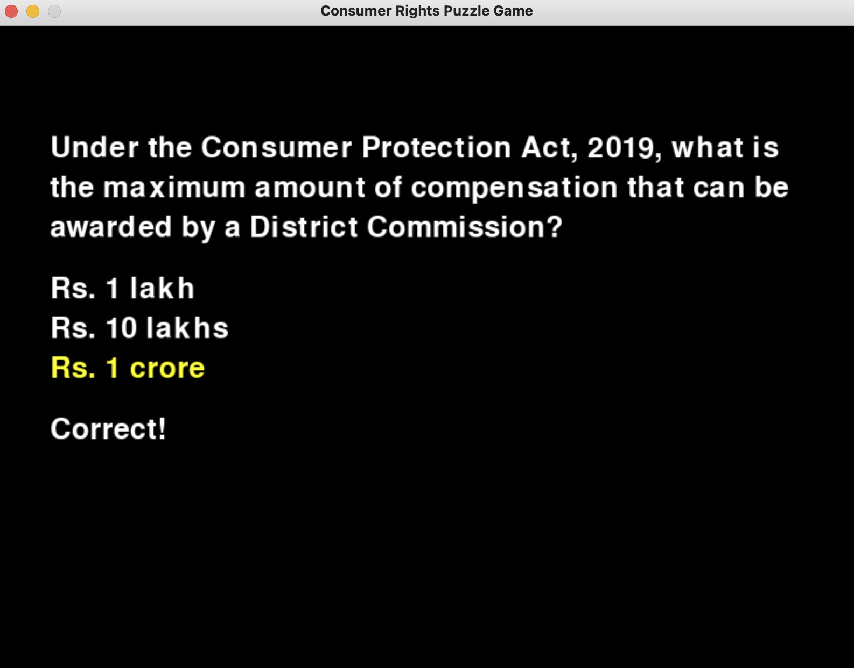

***Figure A1.5 Q&A Generation 2***

As seen in FIG. A5, answering quiz questions elevates players' experiences beyond simple survival to reveal deeper levels of the game. Accurate responses serve as switches, opening doors to new levels full with more difficult obstacles and thrilling interactions. Players explore the nuances of the game more and more as they master each exam, discovering new levels of challenge and intrigue. The advancement system encourages a sense of mastery and accomplishment by rewarding knowledge as well as skill. Players are thrust deeper into the center of the immersive game environment as they progress through these higher levels.

# APPENDIX B SAMPLE CODING

import pygame

import random

from sklearn.naive_bayes import GaussianNB import numpy as np

# # Initialize Pygame

pygame.init()

# # Player

player_image = pygame.Surface((50, 50)) player_image.fill(WHITE)

player_rect = player_image.get_rect(center=(screen_width // 2, screen_height // 2))

# # Dashboard variables

player_name = "Player 1" timing = 0

highest_marks_player = None highest_marks = 0

# # Sample quiz questions

questions = [

{"question": "What is the maximum limit for the consumer complaint to be filed in the district forum?", "options": ["20 lakhs", "1 crore", "10 lakhs", "50 lakhs"], "correct_answer": "20 lakhs"},

{"question": "Which of the following is NOT a consumer right?", "options":

["Right to Information", "Right to Safety", "Right to Education", "Right to Redressal"], "correct_answer": "Right to Education"},

# Add more questions here

]

# # Function to predict difficulty level using Naive Bayes

def predict_difficulty(questions):

# Extract features: question length and number of options

X = np.array([[len(q["question"]), len(q["options"])] for q in questions])

# Labels: define difficulty levels (e.g., 1 for easy, 2 for medium, 3 for hard) y = np.array([1, 2, 3]) # Adjust as needed

# Initialize and train Naive Bayes classifier clf = GaussianNB()

clf.fit(X, y)

# Predict difficulty level for each question return clf.predict(X)

# # Main loop

running = True quiz_completed = False

clock = pygame.time.Clock()

# # Update dashboard

timing += clock.tick(60) / 1000 # Update timing

timing_text = font.render("Time: {:.2f} sec".format(timing), True, WHITE) screen.blit(timing_text, (20, 20))

# # Display player name

player_name_text = font.render("Player: {}".format(player_name), True, WHITE)

screen.blit(player_name_text, (20, 60))

# # Display player with highest marks

if highest_marks_player:

highest_marks_text = font.render("Highest Marks: {} -

{}".format(highest_marks_player, highest_marks), True, WHITE) screen.blit(highest_marks_text, (20, 100))

# # Update display

pygame.display.flip()

# # Quit Pygame

pygame.quit()

# APPENDIX C

**SYSTEM REQUIREMENTS**

# Hardware Specifications:

1. Processor: A modern processor capable of handling graphics rendering and game logic efficiently.
2. Memory (RAM): Sufficient RAM to support the game's graphical assets, logic, and data processing.
3. Graphics Card: A dedicated graphics card capable of rendering 2D or 3D graphics smoothly.
4. Storage: Adequate storage space for the game files, assets, and player data.

# Software Specifications:

1. Operating System: Compatibility with popular operating systems such as Windows, macOS, and Linux.
2. Game Engine: Utilization of a robust game development framework or engine like Unity or Unreal Engine to streamline the development process and ensure cross-platform compatibility.
3. Programming Languages: Proficiency in programming languages such as Python, Tkinter for game logic implementation and integration.
4. Database Management System: Implementation of a database management system to store and manage player data, quiz questions, and answers effectively.

# Source of Consumer Law Data:

1. Access to reliable sources of Indian consumer law data for quiz question generation, ensuring accuracy and relevance.
2. Integration of datasets containing consumer law information to dynamically generate quiz questions and answers based on real-world scenarios.

# APPENDIX D PUBLICATIONS

ASHOK M, KUMAR RAMASAMY, KEERTHANA K, MAHALAXMI K

Presented A Gamified Literacy Analysis Of Indian Consumer Protection Laws in 2 nd International Conference On Recent Advances And Innovation in Science, Engineering, Technology And Management in SCE Conference 2024 at Solamalai College Of Engineering, Madurai on 26/04/2024.

# REFERENCES

[1] Dr. S. Ramesh, “A Comparative Analysis of Consumer Protection Act 1986 and Consumer Protection Act 2019 in India: Strengthening Consumer Rights and Redressal,” Aug-Sept 2023, no. 35. HM Publishers, pp. 1–4, Aug. 04, 2023.https:// doi: 10.55529/jls.35.1.4.

[2]-, D. S. C., & -, Dr. H. M. P. (2023). Study on Consumer Protection Act Awareness Among House Wives with Special Reference Nashik City. In International Journal For Multidisciplinary Research (Vol. 5, Issue 1). International Journal for Multidisciplinary Research (IJFMR). https://doi.org/10.36948/ijfmr.2023.v05i01.1435

1. Dr. Sunil Dsouza, & Mr. Arjun Prakash. (2023). THE SIGNIFICANCE OF FINANCIAL LITERACY FOR CONSUMER PROTECTION: A STUDY OF BANK CUSTOMERS IN DAKSHINA KANNADA DISTRICT. In EPRA

International Journal of Economic and Business Review (pp. 32 –39). EPRA JOURNALS. https://doi.org/10.36713/epra13798

1. “Effectiveness of Consumer Protection Act in Securing Consumer Rights: An Empirical Prospective,” journal of cardiovascular disease research, vol. 12, no. 04. Institute for Advanced Studies, Jun. 18, 2023. https://doi: 10.48047/jcdr.2021.12.04.33
2. S. Agasti, “A BRIEF ANALYSIS ON THE INDIAN CONSUMER PROTECTION ACT, 2020 VS. E-COMMERCE,” International Journal of Advanced Research, vol. 11, no. 05. International Journal Of Advanced Research, pp. 648–653, May 31, 2023. https://doi: 10.21474/ijar01/16917.
3. M.R.Arrasyid, S. M. Art, and M. R. A. Putra, “Implementation of the Electronic Information and Transaction Law on the Culture of Online Buying and Selling Transactions in Protecting Consumers,” JETISH: Journal of Education Technology Information Social Sciences and Health, vol. 2, no. 2. Rayyan Jurnal, pp. 1121– 1126, Sep. 01, 2023. https://doi: 10.57235/jetish.v2i2.812.
4. F. R. Saefudin Junior and L. Sukma Muliya, “Perlindungan Hukum Terhadap Konsumen Terkait Informasi yang Tidak Sesuai Ditinjau dari Undang-Undang Nomor 8 Tahun 1999 Tentang Perlindungan Konsumen,” Bandung Conference

Series: Law Studies, vol. 3, no. 1. Universitas Islam Bandung (Unisba), Jan. 25, 2023. https://doi: 10.29313/bcsls.v3i1.4950.

1. A. Rozzaq Bimantara and E. Pranoto, “Perlindungan Hukum Terhadap Konsumen Yang Dirugikan Dalam Transaksi Jual Beli Barang di Online Shop,” PLEDOI (Jurnal Hukum dan Keadilan), vol. 2, no. 1. Amal Insani Foundation, pp. 69–78, Mar. 15, 2023. https://doi: 10.56721/pledoi.v2i1.189.
2. P. Kumar Singh, “Consumer Protection in India through Criminalisation of Consumer Grievances,” Athens Journal of Law, vol. 9, no. 2. Athens Institute for Education and Research ATINER, pp. 301–318, Mar. 31, 2023. https://doi: 10.30958/ajl.9-2-7.
3. Shatakshi Johri, “Emerging artificial intelligence and its cascading effects on consumer protection in India: An analytical study,” World Journal of Advanced Research and Reviews, vol. 19, no. 3. GSC Online Press, pp. 1553–1558, Sep. 30, 2023.https:// doi: 10.30574/wjarr.2023.19.3.2032
4. Mrs. Archana Mainkar and Dr. Mrs. Anupama Nerurkar, “A Study on the Awareness about Consumer Rights and Consumer Redressal Amongst Students in Mumbai Region,” International Journal of Advanced Research in Science, Communication and Technology. Naksh Solutions, pp. 78 –83, Jan. 30, 2023. https://doi: 10.48175/ijarsct-8115.
5. U. Panasara and B. Asnani, “CONSUMER AWARENESS ON THEIR RIGHTS AND RESPONSIBILITIES: AN EXPLORATORY ANALYSIS FROM GUJARAT,” Gujarat Journal of Extension Education, vol. 2022, no. 1. Society of Extension Education Gujarat, pp. 121–126, Nov. 25, 2022. https://doi: 10.56572/gjoee.2022.si.0023.
6. R. Pawan Bansal, “ROLE OF COMPETITION COMMISSION OF INDIA IN PROTECTING THE INTERESTS OF THE CONSUMERS,” International Journal of Advanced Research, vol. 10, no. 06. International Journal Of Advanced Research, pp. 887–894, Jun. 30, 2022. https://doi: 10.21474/ijar01/14966
7. A. Cahyani, F. Fitriyanti, J. Ahmad, and P. Ramlan, “Consumer Legal Protection from the Decoy Effect Through Digital Literacy,” Substantive Justice International Journal of Law, vol. 5, no. 2. Universitas Muslim Indonesia, p. 193, Dec. 27, 2022 https://doi: 10.56087/substantivejustice.v5i2.196.
8. Anna Maria Tri Anggraini, M. Simanjuntak, A. Safari, R. E. Halim, and S. Riyadi, “Consumer Protection in the Retail and Financial Services Sectors against the Practice of Exoneration Clauses,” Journal of Consumer Sciences, vol. 7, no. 2. Institut Pertanian Bogor, pp. 83–96, Aug. 13, 2022. https://doi: 10.29244/jcs.7.2.83- 96.
9. H. C. Purohit, D. Tomar, K. Arijit, and V. Dabral, “Regression Analysis of the Court Complaints in the District Consumer Forums of Uttrakhand, India,” Delhi Business Review, vol. 23, no. 1. Journal Press India, pp. 73 –86, 2022. https://doi: 10.51768/dbr.v23i1.231202207.
10. Dr. A. Didwal and Dr. R. Negi, “Legal and Economic Perspective of the Consumer Protection Act, 2019 in India: An Overview,” International Journal of Scientific Research and Management, vol. 10, no. 08. Valley International, pp. 375– 383, Aug. 06, 2022.https:// doi: 10.18535/ijsrm/v10i08.lla01.
11. S. S. Rizal, F. O. Alnoor, and K. Laily, “Education on the Legal Aspects of Consumer Protection in Buying and Selling Transactions in the Electronic-based Millennial 5.0 Era (E-Commerce),” IJECA (International Journal of Education and Curriculum Application), vol. 5, no. 2. Universitas Muhammadiyah Mataram, p. 196, Aug. 22, 2022. https://doi: 10.31764/ijeca.v5i2.10208.
12. S. S. Kunder, B. Ronald, and S. Rajesh, “Consumer protection under competition law highlighting relevant market issues under digital market,” International journal of health sciences. Universidad Tecnica de Manabi, pp. 11752– 11762, Jul. 25, 2022. https://doi: 10.53730/ijhs.v6ns5.11054.
13. A. Cahyani, F. Fitriyanti, J. Ahmad, and P. Ramlan, “Consumer Legal Protection from the Decoy Effect Through Digital Literacy,” Substantive Justice International Journal vol. 1, no. 3. Gujarat University, pp. 47 –52, Aug. 31, 2022.https:// doi: 10.55829/ijmpr.v1i3.60.
14. S. Bhat and S. Bhardwaj, “A Comparative Analysis of Competition Law Regimes with the Increase of E-Commerce in India and U.S.A,” ECS Transactions, vol. 107, no. 1. The Electrochemical Society, pp. 19415 –19421, Apr. 24, 2022. https://doi: 10.1149/10701.19415ecst.
15. U. Anand, “A Need of Consumer Protection Act,” International Journal for Research in Applied Science and Engineering Technology, vol. 10, no. 5. International Journal for Research in Applied Science and Engineering Technology (IJRASET), pp. 2185–2185, May 31, 2022. https://doi: 10.22214/ijraset.2022.42791.
16. S. P. Godiyal and K. Singh, “A Comparative Study of Data Protection Laws: Current Global Trends, Challenges and Need of Reforms in India,” VEETHIKA- An International Interdisciplinary Research Journal, vol. 8, no. 2. QTanalytics India (Publications), pp. 11–17, Jun. 30, 2022. https://doi: 10.48001/veethika.2022.08.02.004.
17. Syaparuddin, “CONSUMER PROTECTION LAW IN BUYING AND SELLING GOODS ONLINE,” PAPATUNG: Jurnal Ilmu Administrasi Publik, Pemerintahan dan Politik, vol. 5, no. 2. Goacademica Research and Publishing, pp. 49–54, Nov. 04, 2022. https://doi: 10.54783/japp.v5i2.612
18. Doris Rahmat and Santoso Budi NU, “Socialization of consumer protection against products that harming society,” World Journal of Advanced Research and Reviews, vol. 15, no. 1. GSC Online Press, pp. 262–266, Jul. 30, 2022.https:// doi: 10.30574/wjarr.2022.15.1.0519.
19. Setiawan, P., & Santiago, F. (2021). Consumer Legal Protection on Online Buying and Selling. In Proceedings of the 1st International Conference on Law, Social Science, Economics, and Education, ICLSSEE 2021, March 6th 2021, Jakarta, Indonesia. Proceedings of the 1st International Conference on Law, Social Science, Economics, and Education, ICLSSEE 2021, March 6th 2021, Jakarta, Indonesia. EAI. https://doi.org/10.4108/eai.6-3-2021.2306867
20. Ghapa, N., & Ab Kadir, N. A. (2021). Information Regulation: A Measure of Consumer Protection. In Pertanika Journal of Social Sciences and Humanities (Vol. 29, Issue S2). Universiti Putra Malaysia. https://doi.org/10.47836/pjssh.29.s2.05
21. Muhammad Arif, A. M., Abu Bakar, E., Daud, N. A., & Osman, S. (2021). Legal Protection for Online Consumers and Online Shopping Self-Protection Practices among Malaysian Higher Education Institution Students. In International Journal of Academic Research in Business and Social Sciences (Vol. 11, Issue 12). Human Resources Management Academic Research Society (HRMARS).

https://doi.org/10.6007/ijarbss/v11-i12/1of Law, vol. 5, no. 2. Universitas Muslim Indonesia, p. 193, Dec. 27, 2022. https://doi: 10.56087/substantivejustice.v5i2.196.

1. U. Khandelwal, A. Panicker, and A. Sharma, “Measuring Online Consumer Conformity Among Indian Consumers,” 2021 5th International Conference on Information Systems and Computer Networks (ISCON). IEEE, Oct. 22, 2021.https://doi: 10.1109/iscon52037.2021.9702494.
2. N. Ghapa and N. A. Ab Kadir, “Information Regulation: A Measure of Consumer Protection,” Pertanika Journal of Social Sciences and Humanities, vol. 29, no. S2. Universiti Putra Malaysia, May 17, 2021. https://doi: 10.47836/pjssh.29.s2.05.
3. Davola, A. (2021). Fostering Consumer Protection in the Granular Market. The Role of Rules on Consent, Misrepresentation and Fraud in Regulating Personalized Practices. In SSRN Electronic Journal. Elsevier BV. https://doi.org/10.2139/ssrn.3791265
4. J. Zeno, “Information in Consumer Contracts: Reforming Consumer Protection Law in Malaysia,” Asian Journal of Comparative Law, vol. 17, no. 2. Cambridge University Press (CUP), pp. 242–267, Sep. 16, 2022.https://doi: 10.1017/asjcl.2022.18.